

THE OKLAHOMA PIPELINE ENERGY STORAGE SYSTEM (OPESS) Requirment Analysis Report

By Jonathan Grinnell

Fall 2022



EN.645.800

Mentor Robert Krzystan

|  |  |
| --- | --- |
| Document Name | Reason for Change |
| Grinnell RAR | Initial Document |
| Grinnell RAR_A | Changes made to include Quantitative vs Qualitative descriptions as well as other professor comments. |

Table of Contents

1 Requirement Analysis Report Description 4

2 OPESS ConOps 6

2.1 System Need 6

2.2 System Block Diagram 6

2.2.1 OPESS Block Diagram 6

2.2.2 ESS Block Diagram 7

2.2.3 CaCS Block Diagram 8

3 Requirement Analysis 10

3.1 Interviews 10

3.2 Research 10

3.3 System Requirements 10

3.4 Requirement Verification 11

3.5 Key Performance Parameters 12

3.6 Requirements Metric 13

4 Earned Value Management 14

4.1 Schedule 14

4.2 Milestones 15

4.3 EVM 15

4.4 CPI and SPI Index 16

5 Risk 16

5.1 Risk 1: Weather 17

5.2 Risk 2: Earthquake 17

5.3 Risk 3: Residual Natural Gas 18

5.4 Risk 4: Cyber Security 18

6 References 19

7 Appendix A: Cyber Security Expert Interview 20

8 Appendix B : Utility Economist Interview 22

9 Appendix C: Requirements 24

9.1 Originating Requirements 24

9.2 Design Constraints 27

9.3 Performance Requirements 31

9.4 Functional Requirements 39

10 Appendix D: Verification Cross Reference Matrix 0

**Table of Figures**

Figure 1: OPESS Block Diagram 7

Figure 2:ESS Block Diagram 8

Figure 3: CaCS Block Diagram 9

Figure 4: Requirement Analysis Report Schedule 14

Figure 5: Functional Analysis Report Schedule 14

Figure 6: Risk 1 Weather 17

Figure 7: Risk 2 Earthquake 17

Figure 8: Risk 3 Residual Natural Gas 18

Figure 9: Risk 4 Cyber Security 18

**Table of Tables**

Table 1: MOE Summary 5

Table 2: Scenario Summary 5

Table 3 List of Solution Needs 6

Table 4: Requirement Type 11

Table 5: Verification Method 11

Table 6: Key Performance Parameters 12

Table 7: KPP Description 12

Table 8: Requirements Metric 13

Table 9:Milestones 15

Table 10: CPI/SCI 16

# 1 Requirement Analysis Report Description

The **Requirements Analysis Report (RAR)** will be delivered as the second delivery of the **Oklahoma Pipeline Energy Storage System (OPESS)** after the proposal is turned in and accepted. This report will be composed of a Concept of Operations as well as an analysis of the developed requirements. Schedule, EVM and CPI/SPI will also be discussed during this project. The risks first detailed in the OPESS proposal will be updated with any risk reduction efforts that were performed in the requirement development phase of the OPESS Project.

The concept of operations will provide a description of the functional need that the OPESS aims to fill. It will focus on spelling out the current make up of the Oklahoma power grid, its increasing reliance on renewable sources of energy and why a new energy solution will be needed to meet future demand. After that, the ConOps will dive further into the design of the OPESS system through the use of block diagrams in an attempt to flesh out the two subsystems that compose the OPESS.

The requirements analysis section with not in and of itself list out the requirements. A full list of requirements can be found in the Appendixes below. The requirement analysis section will consist of tables discussing the types of requirements that were written and how they plan to be tested initially. A further analysis of the test plan with possible updates will be provided in the Test Procedure delivery at a future date.

This document will also provide an update of the EVM as it stands as of this writing. Schedule updates, deliveries, the WBS and SPI/CPI will be discussed in this section

Risks will be the last real section of the RAR. In this section, the risks outlines in the initial proposal will be updated and new risk reduction techniques developed during the requirement development stage will be taken into account.

Lastly, four appendixes will be attached to this document. These appendixes will be a listing of interviews as conducted for the research of the RAR with the cyber security expert and the utility economist as well as a breakdown of the requirements and a verification cross reference matrix. Since this is formation is fairly long winded and not written in a form conducive to a report, it was thought best to keep it in a separate format for reference purposes.

Two interviews were conducted. The first interview was conducted with a cyber security expert. The OPESS system will rely heavily on communication through the internet so an understanding of how that connection might be secured was important to get.

The second interview was conducted with an economist with a utility company. This economist provided important insight into how power plants generate electricity and sell it on the grid. An understanding of that interaction, how electrical needs are modeled into the future and how power is bought and sold would be important in the design of the OPESS.

The requirements for the OPESS were written based on input acquired from these interviews, research and the overarching system need. These requirements, once written and broken down were input into a MBSE tool called CORE. Here, these requirements could be further linked, KPP’s and verification method identified and a VCRM built. CORE will be further updated with the associated functions in the FAR delivery.

All KPP’s listed in section 3.5 trace to MOE 2 through MOE 4. These MOEs can be found in the table below.

Table 1: MOE Summary

|  |  |
| --- | --- |
| MOE Number | Summary |
| MOE 1 | The energy efficiency of the OPESS must be high enough to be of worth to the market. |
| MOE 2 | The ESS must be able to store energy on the time span of months to years. |
| MOE 3 | The OPESS much adhere to proper cyber security standards. |
| MOE 4 | The ESS should be able to stand up to the elements. |
| MOE 5 | The OPESS must not produce carbon emissions. |

MOE 1 was left was not referenced by the KPPs since that particular MOE is really more of a market and financial requirement. This MOE is still an important one to have listed and reference as this requirement will ultimately be what decides the viability of the OPESS system.

The scenarios listed in the proposal, which can also be found below, were important to the creation of the OPESS RAR, however, they were a bit generic. The OPESS works in much the same way as a big, mechanical battery and in theory, should be able to do all the things a battery can do. As such, scenario 1 though 3 may be a bit generic. They are however, interesting discussion points and would be extremely important when discussing MOE 1.

Table 2: Scenario Summary

| Scenario Number | Summary |
| --- | --- |
| Scenario 1 | An overgeneration of power has led to a surplus of electricity on the grid. The OPESS store that power to keep the grid from being overloaded. |
| Scenario 2 | An under generation of power has led to a potential brownout situation. The OPESS will generate power using it’s stored reserves. |
| Scenario 3 | The OPESS system both generates and stores power on the grid at the same time. This smooths out the variates in the demand curve allowing for a better maintained grid. |

# 2 OPESS ConOps

## 2.1 System Need

In 2010 Oklahoma mandated that 15% of the states energy needs be provided by some form of renewable energy source. As early as 2012 the state surpassed that goal (Popovich & Plumer, 2020). In 2021, the amount of energy produced by renewable sources accounted for 45% of the states energy needs. That number continues to increase as new wind projects are stood up and roof top solar becomes more popular. Unfortunately, wind and solar are not a source of consistent power. When the sun goes down homeowners are forced to either pull power from a grid that still produces energy primarily from dirty sources or from an expensive battery pack. High pressure systems can also move in, causing time periods of low wind energy production or worse yet, strong winds can come in during storm season and produce an excess of wind energy, forcing wind turbines offline.

The solution is to install large amounts of grid level energy storage. This will help even out the peaks and valleys of energy production, allowing energy produces on high energy days to be used on low energy days. Batteries are expensive and will compete with electric cars as their demands rises and pumped hydro can’t really be used in Oklahoma as the state neither gets the required amount of rain or has enough in the way of mountains to make it practical.

What the state does have in abundance are natural gas wells. It is through the use of this resource common to the state that a form of green energy storage can be developed. A list of solution needs can be found is table 1.

Table 3 List of Solution Needs

|  |  |  |
| --- | --- | --- |
| Number | Name | Description |
| 1 | Extra Storage | The OPESS needs to be able to store extra energy from renewable sources during times of over production. |
| 2 | Low-Cost Storage | The OPESS needs to be able to store energy produced on the grid during low rates for use during times of high rates |
| 3 | Long Term Storage | The OPESS needs to be able to store energy for a significant amount of time with minimal loss. This will be measured on the timeframe of months to years. |
| 4 | Grid Scale Storage | The OPESS needs to be able to provide an energy storage solution that can be maintained on a grid level. |

## 2.2 System Block Diagram

### 2.2.1 OPESS Block Diagram

The OPESS is composed of two major subsystems. The first is the Energy Storage Subsystem (ESS). The ESS is the actual storage system of the OPESS system. Functionally, it pulls power off the grid, compressed air for storage in spend natural gas wells, and then used that gas to spin a turbine for use on the grid. Since this device is outside, it is exposed to the elements and will thus need to be protected.

The second major subsystem is the Command-and-Control Subsystem (CaCS). As it’s name suggests, it performs the command-and-control functionality of the OPESS system. The CaCS allows communication between the OPESS and other utility companies and plants that might be powering the grid at the time. The CaCS communicated with the ESS over a secured internet connection.

Figure 1: OPESS Block Diagram

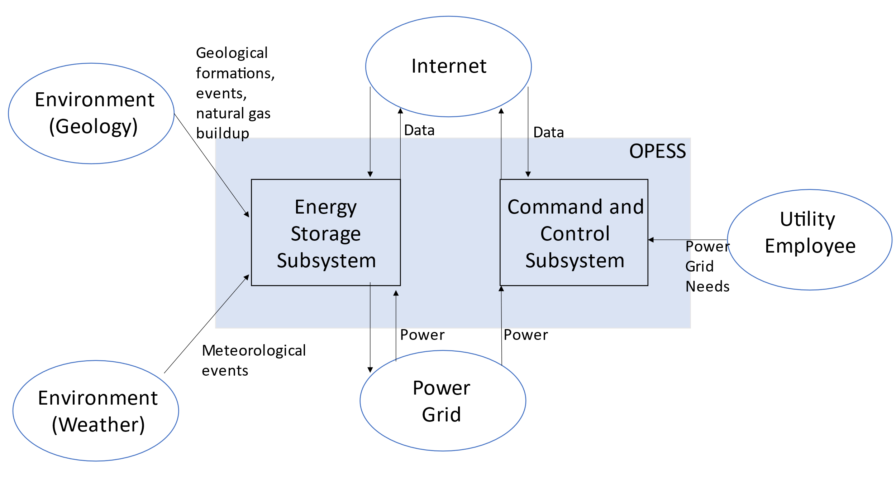

### 2.2.2 ESS Block Diagram

The ESS is the heart of the OPESS. It is composed of 5 functions, receive power, store power, generate power, a control node and weather protection. The primary function of the ESS is to act as a battery, hence the first three functions, however, unlike a batter, this is a complicated piece of equipment with lots of moving parts. A localized control note will have to be included in order to tell the individual components of the ESS how to behave. Additionally, this node will communicate with the CaCS and report and health and status issues the ESS might be experiencing.

Additionally, per risk 1, the ESS will be exposed to the elements on a regular bases and Oklahoma is famous for its bad weather. The final function, weather protection, is a risk reduction function meant to protect the ESS.

Figure 2:ESS Block Diagram

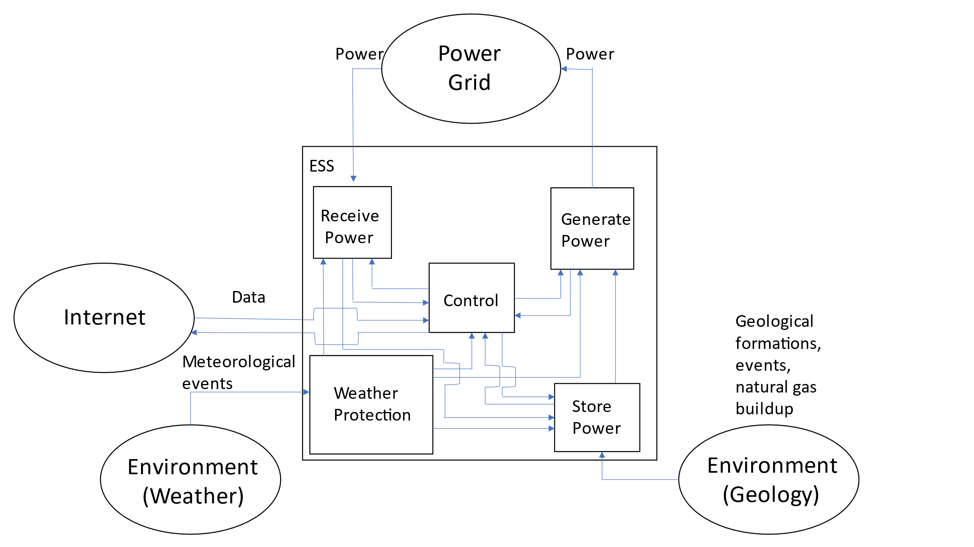

### 2.2.3 CaCS Block Diagram

The CaCS is the brains of the OPESS system. It exists primarily as a an office space that allows utility workers, economists and engineers to communicate with other facilities both locally and across state lines in a effort to figure out what the future and current electrical needs will be. The CaCS will be able to allow employees access to modeling software in an effort of predict the future needs of the OPESS system on the grid. The CaCS will also allow employees to log into the ESS from their desk, monitor health and status and even control the ESS with out having to go into the field. This will be helpful as issues can be diagnosed and handled with out sending out technicians into the field.

Figure 3: CaCS Block Diagram

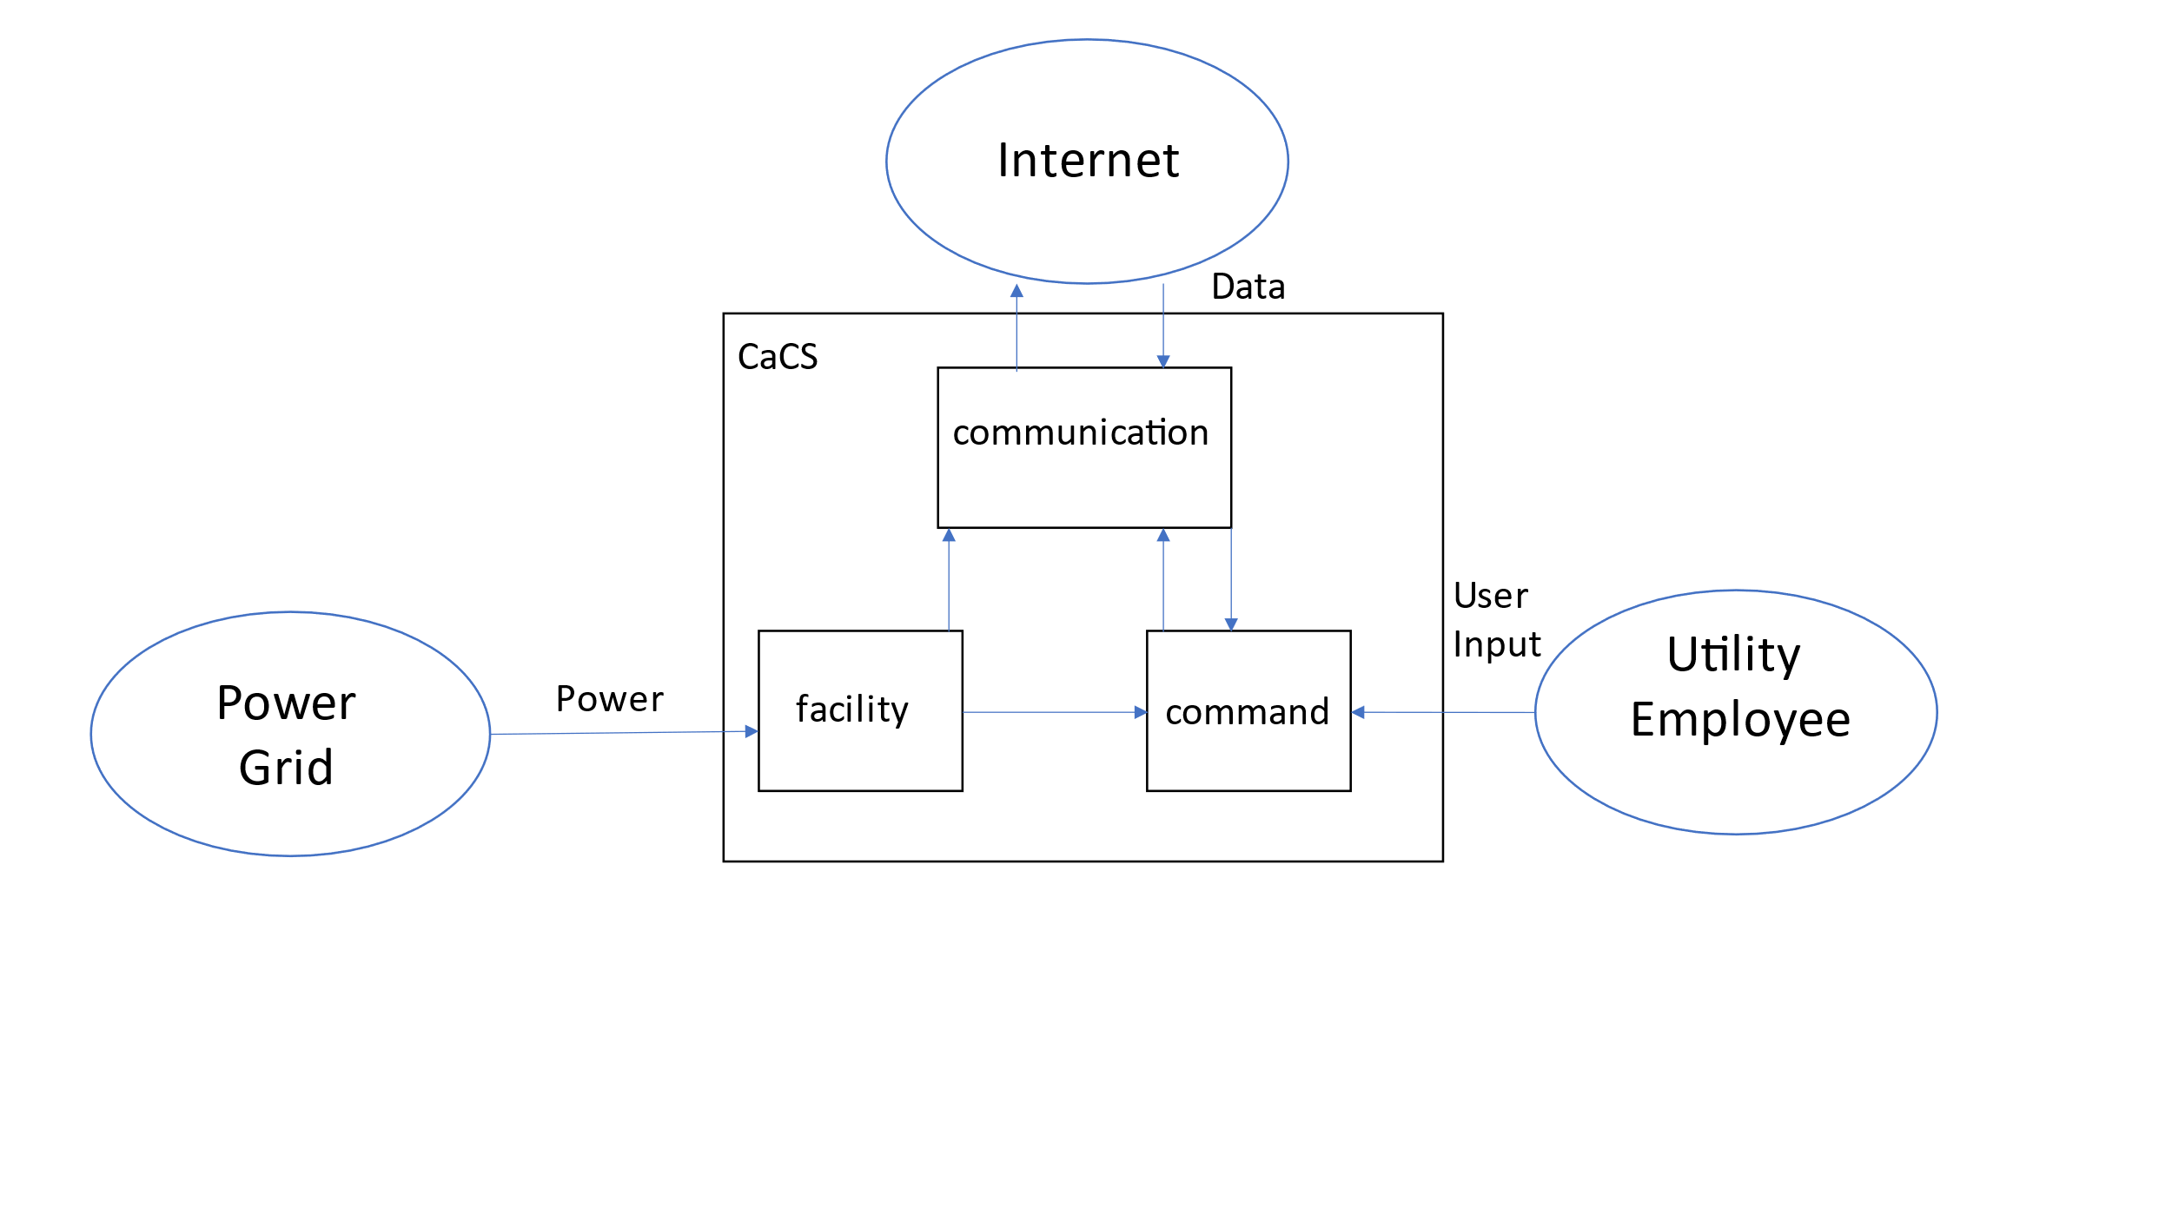

# 3 Requirement Analysis

## 3.1 Interviews

As a part of conducting research for the OPESS system, interviews with subject matter experts were conducted. A cyber security expert, economist for a utility company and petroleum engineers were all contacted and sent questionnaires so as to gain an understanding of the functionality the system might need relative to their field.

Per risk 4, the OPESS is open to cyber attack by its connection to the internet. Additionally, the since the OPESS is tied into the power grid, it would be considered critical infrastructure and thus a prime target for aggressive actors. As such, the aid of a cyber security expert was sought out. Through their interview, advice was given in how to secure both the ESS and the CaCS, allowing them to communicate while keeping the risk down to a reasonable level.

It was also not known how a utility company is able to effectively predict and generate power in a way that maintains grid stability. For this, an economist with experience in setting electrical rates was sent a questionnaire. This provided valuable insight into power usage modeling, how far out that modeling goes as well as its accuracy. It also helped to explain how utility companies interact with other companies both local and out of state. This information would be critical in the design of the CaCS.

Requests for interviews were also send to petroleum engineers local to Oklahoma. It was hoped that an interview might be able to shed light into the inner workings of natural gas wells as well as answer questions regarding risk 3, residual natural gas. Unfortunately, no petroleum engineers ever agreed to be interviewed. Additional attempts will be made during the course of OPESS development.

These interviews can be seen in Appendix A and B.

## 3.2 Research

Research was also conducted to supplement the information given by the interviewees. The focus was primarily on natural gas wells and how the power grid operates. However, as it turns out, research has already been done by the Department of Energy into storing power in spent natural gas wells specifically in regards to risk 3. This paper was able to supplement a lot of the information that was otherwise missing and requirements were able to be written.

## 3.3 System Requirements

The requirements written for the OPESS system can be broken up into four different types:

Originating Requirements: The requirements stem from interviews from experts on various topics. They sometimes fill a performance or functional role in the OPESS system and can mostly be found labeled as both a originating and a performance/functional requirement.

Design Constraint: Design Constraints are choices that were made on the part of a requirement to achieve a goal. For example, “shall store energy” may be a functional phrase but “shall use a natural gas well” is a design choice on the part of the OPESS system.

Performance Requirements: Performance Requirements are any requirement that specifies some measure of performance of the OPESS system. These can be found as percentages, amounts or minimal standards as in the case of some software requirements.

Functional Requirements: Functional Requirements are requirements that provide or describe a function of the system. The phrase “shall store energy” describes a function of the OPESS system.

Table 4: Requirement Type

|  |  |
| --- | --- |
| Requirement Type | Number |
| Originating Requirements | 15 |
| Design Constraints | 21 |
| Performance Constraints | 44 |
| Functional Constraints | 38 |
| Total | 118 |

Additionally, since some of the Originating Requirements can double as both Functional or Performance most of them have actually been counted twice in the OPESS system with the exception of one. As such, that 118 number presented in Table 2 should actually read 104.

## 3.4 Requirement Verification

The requirements are verified through four verification methods.

Inspection: An inspection requirement is any requirement that can be verified via looking or some form of observation. Potential examples could be something like confirming a piece of software is coded per requirement or looking at a documented spec from a supplier.

Analysis: An analysis requirement is any requirement that requires multiple runs so that data can be built up. This data can then be analyzed to confirm that the behavior meets the requirement.

Demonstration: A demonstration requirement is any requirement that requires a demonstration of the functionality. An example might be like confirming that a pipe can hold up to 30 psi. Once the pipe is filled to that level, the requirement passes.

Test: A test requirement is any requirement that requires some form of formal test procedure. These can be related to demonstration requirements but typically require confirming consistent behavior of the system under multiple situations.

Table 5: Verification Method

|  |  |
| --- | --- |
| Verification Method | Number |
| Inspection | 29 |
| Analysis | 14 |
| Demonstration | 37 |
| Test | 24 |
| Total | 104 |

## 3.5 Key Performance Parameters

Key performance parameters (KPP’s) are requirements that were developed specifically to dictate key functions or standards important to the OPESS. These requirements form the backbone of the system.

Table 6: Key Performance Parameters

|  |  |
| --- | --- |
| Key Performance Parameters | Number |
| True | 12 |
| False | 92 |

Table 7: KPP Description

| KPP # | Req. # | Req. Name | Req. Description | Quantitative Vs. Qualitative | Verification Method |
| --- | --- | --- | --- | --- | --- |
| 1 | 1.1.1.5 | ESS Internet Interface | The ESS control node shall maintain a secure connection with the CaCS. | Qualitative | VerificationRequirement Test |
| 2 | 1.1.2.1.3 | ESS Generator Storage Interface | The ESS generator shall use compressed air coming from the natural gas well to spin a turbine and generate power. | Qualitative | VerificationRequirement Demonstration |
| 3 | 1.1.2.4.1 | ESS Carbon Capture Percent | The ESS carbon capture system shall remove no less then 50 percent of the hydrocarbons from the compressed air. | Quantitative | VerificationRequirement Test |
| 4 | 1.1.3.2.2 | ESS Storage Time | The ESS storage shall be able to keep compressed air for a period of up to 1 year. | Quantitative | VerificationRequirement Demonstration |
| 5 | 1.1.3.3.2 | ESS Storage Gas Safty Sensor | The ESS pressurized connection shall have an emergency release when the gas mixture reaches 4% according to the sensors. | Quantitative | VerificationRequirement Test |
| 6 | 1.1.3.3.4 | ESS Storage Leak | The ESS shall not allow the pressurized connection to leaked at a rate of more than 5% a year. | Quantitative | VerificationRequirement Test |
| 7 | 1.1.3.3.5 | ESS Storage Pressure | The ESS pressurized connection shall be able to handle up to 300 PSI. | Quantitative | VerificationRequirement Test |
| 8 | 1.1.4.1.1 | ESS Air Compressor | The ESS pump shall compress air and send it to the natural gas interface at pressure. | Qualitative | VerificationRequirement Demonstration |
| 9 | 1.1.5 | ESS Weather | The ESS shall be protected from the weather. | Qualitative | VerificationRequirement Test |
| 10 | 1.2.1.3 | CaCS Syber Security | The CaCS shall have a secure connection to the internet. | Qualitative | VerificationRequirement Test |
| 11 | 1.2.3 | CaCS Utility Interface | The CaCS shall receive data and commands from local utility employees. | Quantitative | VerificationRequirement Demonstration |
| 12 | 1.2.3.6 | CaCS Models | The CaCS shall provide software capable of creating and using utility models. | Qualitative | VerificationRequirement Demonstration |

## 3.6 Requirements Metric

The below table presents a list of all the metrics regarding the requirements derived for the RAR. This table will summarize the number of total requirements, PKK’s, qualitative vs quantitative and how each requirement will be verified.

Table 8: Requirements Metric

| Requirement Data Type | Number of Requirements |
| --- | --- |
| Total Requirements | 104 |
| Total Qualitative Requirements | 50 |
| Total Quantitative Requirements | 54 |
| Verification by Inspection | 29 |
| Verification by Analysis | 14 |
| Verification by Demonstration | 37 |
| Verification by Test | 24 |

# 4 Earned Value Management

## 4.1 Schedule

While the requirements were being written, it was found that requirements were coming out more thought out and broken down when done in conjunction with a functional decomposition. As such, the Requirements Analysis Report was pushed back a few weeks due to an increase in scope. However, since the functions have already been created, those tasks can complete under the Functional Analysis Report. As such, the OPESS schedule is over all showing a little bit ahead.

Figure 4: Requirement Analysis Report Schedule

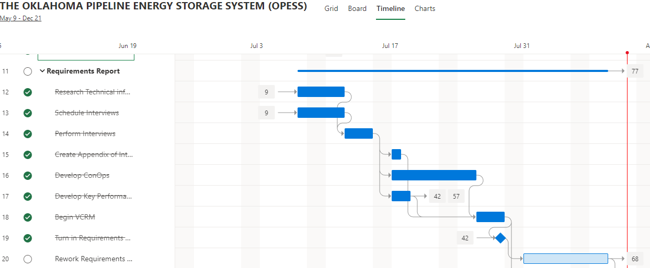

Figure 5: Functional Analysis Report Schedule

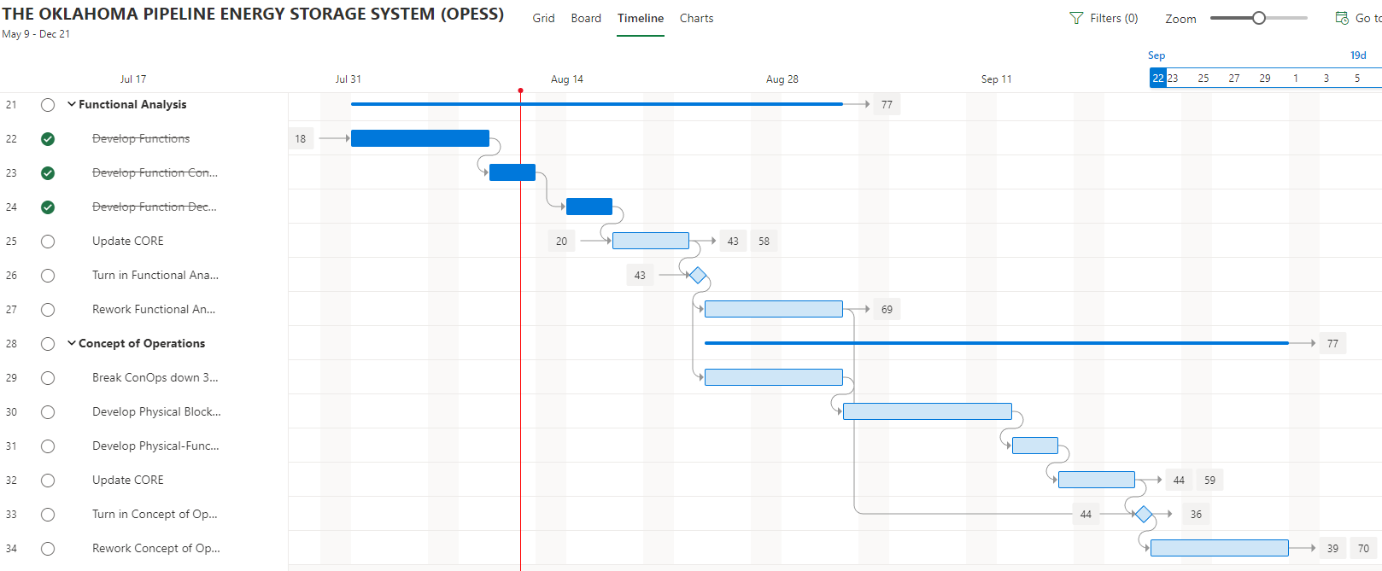

## 4.2 Milestones

Items in red were turned in late per the original due date. All other deliveries are expected to be on time.

Table 9:Milestones

| **Milestone** | **Date** |
| --- | --- |
| Project Proposal | 7/8/2022 |
| Requirements Report | 8/12/2022 |
| Functional Analysis | 8/23/2022 |
| Concept of Operations | 9/21/2022 |
| Trade Study | 10/7/2022 |
| Risk Management Report | 10/21/2022 |
| Test Plan | 11/11/2022 |
| System Specifications | 11/30/2022 |
| Final Report | 12/12/2022 |
| Oral Presentation | 12/16/2022 |

## 4.3 EVM

|  |  |  |  |  |  |  |  |
| --- | --- | --- | --- | --- | --- | --- | --- |
| WBS number | Name | % Complete | Budget | BCWP | ACWP | SPI | CPI |
| **3** | **Requirements Report** | **83.33%** |  |  |  |  |  |
| 3.1 | Research Technical information | 100.00% | 6 | 6.00 | 4 | 1 | 1.50 |
| 3.2 | Schedule Interviews | 100.00% | 3 | 3.00 | 1 | 1 | 3.00 |
| 3.3 | Perform Interviews | 100.00% | 3 | 3.00 | 2 | 1 | 1.50 |
| 3.4 | Create Appendix of Interviews and Site Sources | 100.00% | 3 | 3.00 | 0.5 | 1 | 6.00 |
| 3.5 | Develop ConOps | 50.00% | 5 | 2.50 | 6 | 0.5 | 0.42 |
| 3.6 | Develop Key Performance Parameters | 100.00% | 3 | 3.00 | 1 | 1 | 3.00 |
| 3.7 | Begin VCRM | 100.00% | 2 | 2.00 | 0.5 | 1 | 4.00 |
| 3.8 | Turn in Requirements Report | 100.00% | 0.5 | 0.50 | 3 | 1 | 0.17 |
| 3.9 | Rework Requirements Report | 0.00% | 10 | 0.00 |  | 0 | #DIV/0! |
| **4** | **Functional Analysis** | **50.00%** |  |  |  |  |  |
| 4.1 | Develop Functions | 100.00% | 10 | 10.00 | 6 | 1 | 1.67 |
| 4.2 | Develop Function Connectivity | 100.00% | 5 | 5.00 | 7 | 1 | 0.71 |
| 4.3 | Develop Function Decomposition | 100.00% | 5 | 5.00 | 6 | 1 | 0.83 |
| 4.4 | Update CORE | 0.00% | 3 | 0.00 |  | 0 |  |
| 4.5 | Turn in Functional Analysis | 0.00% | 0.5 | 0.00 |  | 0 |  |
| 4.6 | Rework Functional Analysis | 0.00% | 10 | 0.00 |  | 0 |  |

## 4.4 CPI and SPI Index

Table 10: CPI/SCI

# 5 Risk

No new risks were discovered when writing the RAR. The OPESS risks were all developed through an interaction from the OPESS with the outside world in some way. Experts were interviewed and asked specifically about some of the risks listed below. Their input was used to write detailed requirements that would effectively help to reduce some of the risk on the OPESS system.

## 5.1 Risk 1: Weather

Figure 6: Risk 1 Weather

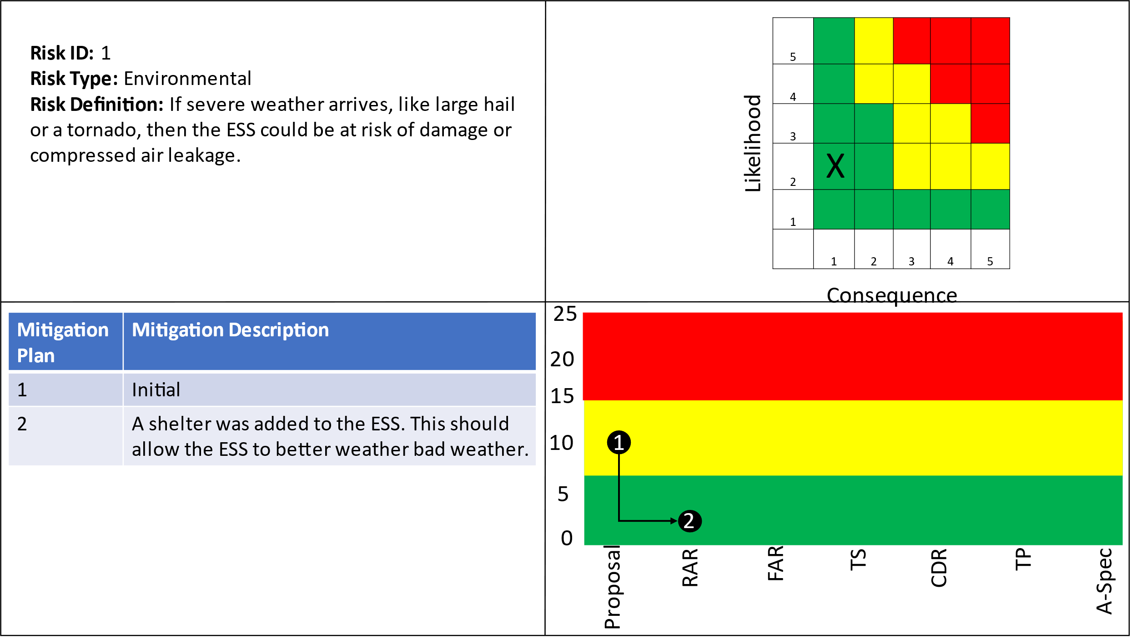

## 5.2 Risk 2: Earthquake

Figure 7: Risk 2 Earthquake

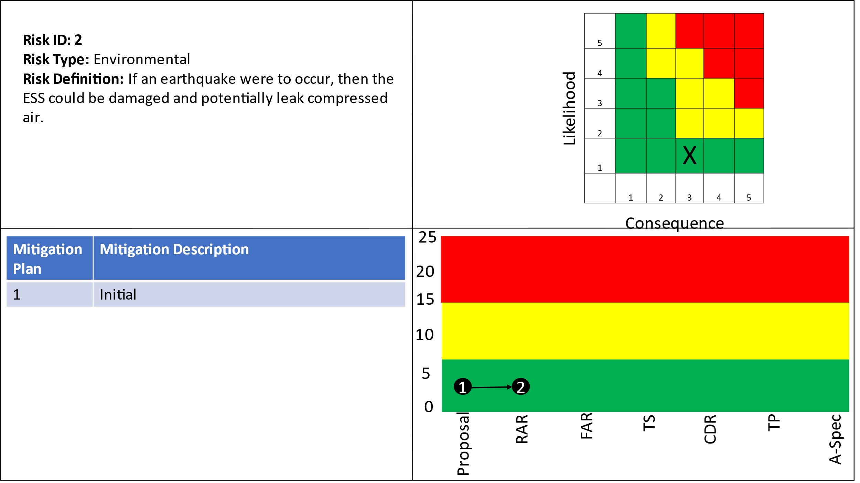

## 5.3 Risk 3: Residual Natural Gas

Figure 8: Risk 3 Residual Natural Gas

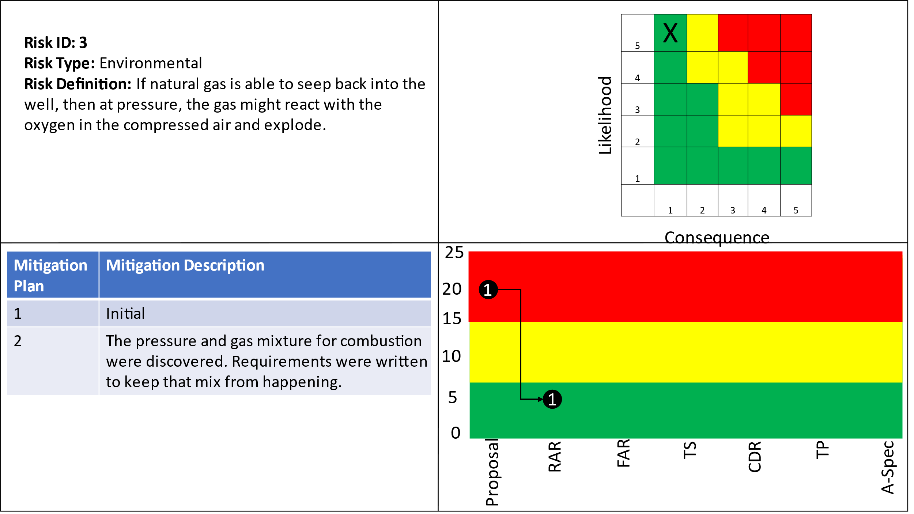

## 5.4 Risk 4: Cyber Security

Figure 9: Risk 4 Cyber Security

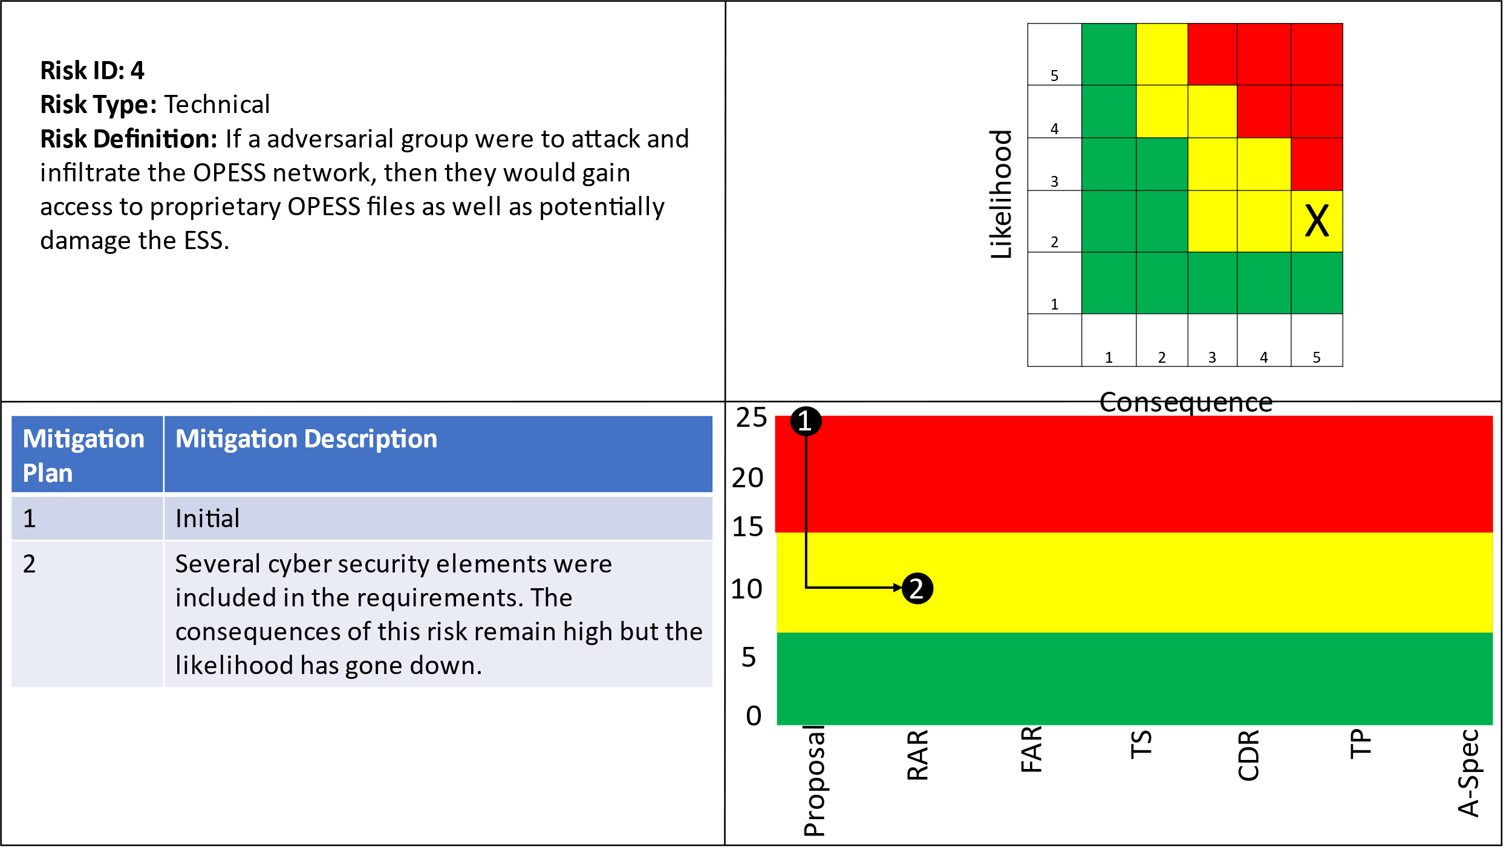

# 6 References

*Electricity explained: How electricity is delivered to consumers.* (2022, August 11). Retrieved from US Energy Information Administration: https://www.eia.gov/energyexplained/electricity/delivery-to-consumers.php

Grubelich, M. C., Bauer, S. J., & Cooper, P. W. (2011, September). *Potential Hazards of Compressed Air Energy Storage in Depleted Natural Gas Reservoirs.* Retrieved from Sandia Report: https://www.osti.gov/servlets/purl/1029814/

Popovich, N., & Plumer, B. (2020, 10 28). *How Does Your State Make Electricity?* Retrieved from The New York Times: https://www.nytimes.com/interactive/2020/10/28/climate/how-electricity-generation-changed-in-your-state-election.html

*The Basics of Underground Natural Gas Storage* . (2015, 11 16). Retrieved from US Energy Information Administration: https://www.eia.gov/naturalgas/storage/basics/

U.S. Energy Information Administration. (2022, May 19). *Oklahoma State Profile and Energy Estimates*. Retrieved from U.S. Energy Information Administration: https://www.eia.gov/state/analysis.php?sid=OK

## 

# 7 Appendix A: Cyber Security Expert Interview

| Interview Questionnaire |
| --- |
| 1. What standards should be involved when connecting critical infrastructure in the form of a power plant to the electrical grid? |
| I assume you are talking about network/comms standards. If you aren’t constrained by legacy technology nowadays its all standard TCP/IP, IEEE 802.3 Ethernet, Fiber Optic cabling for most outdoor applications, and if you aren’t too risk averse the IEEE wireless standards (802.11, 802.15, etc.). I’m not too familiar with the standards but you likely want equipment that meets standards for industrial use (water, vibration resistant, etc.) – there should be things similar to MILSPEC for that. |
| 1. What encryption scheme would you recommend for use between two locations? |
| Pretty much anything AES-256 or stronger. Given its US and critical infrastructure I wouldn’t be surprised if that is the mandated minimum. |
| 1. What are some things that you would be looking for in a firewall? |
| I prefer a firewall that has advanced features like IPS, TLS inspection, URL filtering, etc. – something like a Palo Alto. Since your not building a “normal” office type infrastructure you’ll probably need more than one at your ‘border’ to segment and control traffic across internal ‘domains’. I like to have a firewall that develops IPS signatures that are different than the signatures the host-based anti-virus uses for more effective coverage. You might also consider a passive IDS (Intrusion Detection System – Snort is an example) for key locations that besides the passive sensor is completely separated from all the other infrastructure. |
| 1. What are some things that you would be looking for in an anti-virus? |
| Most anti-virus covers a range of protective functions on a computer; I think for your application pick one that is reputable and has a high detection rate. You definitely want one with a central console (e.g. – MacAfee) where you can check and alert on detections as well as whether signatures are current and ‘real-time’ protection is on. For example, you want alerts if something turns off the anti-virus on a system or a system isn’t current with signatures. |
| 1. Would you suggest a form of two factor authentication? If so, what type would be the most appropriate? |
| For users absolutely, MFA… and logging and monitoring that detects potential misuse… is essential for anyone logging onto an actual computer. More challenging is the ICS/SCADA side… likely many systems do not support MFA and these should be not directly accessible (e.g. – an operator needs to go through a MFA secured ‘jump box’ before being able to SSH to a controller). For devices that support it using certificate based authentication is probably preferable but it is complicated to setup and maintain. |
| 1. Do you have any advice on setting up a VM for both onsite use and for connecting to computers that are kept off site? |
| Without getting too complicated follow reasonable best practices for hardening and operation. For example VMware has plenty of guides… you could also look at DISA STIGS (https://public.cyber.mil) for a comprehensive control set. Remember though, implement controls that make sense in your environment and risk profile. |
| 1. What NIST standards to you suggest looking at to make sure the network is secure? |
| The fundamental cyber standards for cybersecurity controls are in the 800-53 realm, though that is most applicable to “standard” computing and network infrastructure. On first read of your proposal you have lots on controllers, SCADA, etc. so you probably want to look at the NIST 800-82 Guide to Industrial Control Systems (ICS) Cybersecurity. There are probably more regulatory controls and guidelines you should/must follow for a system like this – you might want to poke around the Energy ISAC (Information Sharing and Analysis Center) for more information: https://www.isao.org/information-sharing-group/sector/electricity-isac/ |
| 1. Is there anything you can think of that you feel might be important? |
| Three things come to mind… first have a design that keeps operational functions (ICS/SCADA/etc.) separate to the maximum extent possible from more general purpose administrative computing infrastructure. While it may garner a laugh in movies, seeing someone playing Wordle at an ICS admin console would be a red line for me.  Second, if this is a “green field” design (you aren’t integrating existing infrastructure to ‘build’ this system) you have a lot more latitude to implement appropriate cybersecurity measures across the system. If you have legacy infrastructure you will have to find a way to ‘wrap’ or partition it with compensating control. Finally, try to make sure you have done a risk analysis and are placing appropriate controls in the areas and infrastructure where it is most needed. An extreme example is buying the most expensive firewall and relying on it instead of a layered defensive strategic than ensures a broad but manageable set of preventative and detective controls. |

# 8 Appendix B : Utility Economist Interview

|  |
| --- |
| Interview Questionnaire: **Christina Leinneweber** |
| 1. What is involved in a utility company selling power to another company across state lines? |
| Utilities that are involved in transactions that affect the “[bulk electric system](https://www.energy.gov/sites/prod/files/2017/09/f36/NERC%20Glossary.pdf)” are regulated by the North American Electric Reliability Corporation (NERC). Depending on the particulars of a utility’s holdings (generation, transmission, both) and responsibilities (serving retail customers or just participating in the wholesale market), NERC imposes appropriate regulations. The Federal Energy Regulatory Commission (FERC) also imposes various safety and reliability regulations on all utilities except those in Texas (which has established its own in-state-only grid, ERCOT, to avoid Federal regulation). Investor-owned utilities (IOUs) are also regulated by FERC regarding rates, business practices, and accounting & reporting standards. For example, FERC attempts to encourage competition and access in the transmission system by requiring that IOUs file an Open-Access Transmission Tariff (OATT) according to certain rules. This is the rate that one utility will charge another for use of its transmission lines, and cannot be more expensive than the implied cost a utility incurs to serve itself.  How the utility transacts in the wholesale market depends on the market structure. A transaction can be a simple bilateral transaction, where one utility sells a fixed about of power to another for a fixed time, using a designated transmission path (either the utiity’s own lines or a path purchased from another transmission owner). Most US markets are organized into Independent System Operators ([ISO](https://www.youtube.com/watch?v=w63C6Nd1MzQ)s), however, where all the utilities that want to buy and sell power bid/request for electricity, and the buyers are matched with the most competitive sellers.  Public utilities are not under FERC regulation because they are regulated by their own local governments already. However, sometimes publics voluntarily comply with FERC regulations in order to more efficiently compete on the wholesale markets where everyone else is already using the FERC template. (For example, Tacoma Power has an OATT calculated according to FERC rules.) |
| 1. What is involved in a utility company selling power to another company internally to the state? |
| The differences across state lines are mainly financial and regulatory. The same buying and selling occurs, but different state commissions will be in charge of approving retail rates in each jurisdiction. The various states might also have different rules regarding minimum amounts of renewables, conservation targets, *et cetera*. |
| 1. How are electric hourly rates set? |
| On the wholesale market, this is a competitive bidding process (in an ISO) or a mutually-agreed contract (in a bilateral trade). For retail customers, the utility must prove to the commission or other relevant regulatory body that the rates recover allowable costs (*i.e.* costs for things the utility is approved to spend money on). IOUs also are allowed a certain rate of return for investors. |
| 1. How are electric rates set in the timespan of months? |
| ISOs generally work on an hourly or sub-hourly basis. Bilateral swaps can be for any length of time to which the parties agree. On the retail side, the utility proposes the kind of rate structure (same price all the time, different prices at peak times, *etc.*) to the regulators based on the cost structure of the utility and if there is a benefit to shaping consumer behavior. |
| 1. How does the utility know when to generate more or less energy? |
| In the very, very, very, very short term, the utility knows if generation is getting out of balance with load if the grid frequency drops above or below 60 Hz. This allows for the minute balancing. On a more hourly basis, the utility is always monitoring generation, purchased electricity imports, and output to the substations in real time. Various short-term models take the real-time data and project out for the next few hours and days based on historical trends (for day of week, season, *etc.*) and weather forecast. Generation plans for the hour, day ahead, week ahead, and month ahead are constantly being fine-tuned. Over the very long term, econometric modeling is used to produce a long-term (decades ahead) forecast for the purposes of determining if a new resource (like a new power plant) is needed. |
| 1. When determining how much energy to produce, do you use models are look at actual numbers coming in? |
| See above. |
| 1. If models are used, how accurate are they? |
| The shorter the time horizon in the future, the more accurate! The biggest driver of day-to-day fluctuations in energy usage is weather, so the forecast is much better for time periods over which weather can be predicted. |
| 1. How well does the grid handle sudden changes in demand? |
| This depends on generation mix. Hydroelectric and natural gas resources are the most flexible. Coal takes much longer to ramp, and solar/wind cannot be fine-tuned to load. |
| 1. How do smaller generators like rooftop solar integrate into the grid? |
| Policies about customer generation depend widely on jurisdiction. Some jurisdictions meter all the power that the solar unit produces and pays a certain rate to the customer for that generation. Then they separately meter all the power that the customer facility uses, and bill the customer for it like a normal customer. How much is paid for the solar generation can vary widely based on whether regulators are trying to pay the market value for the power, or to pay above-market as a subsidy. Other jurisdictions net the energy used/energy consumed over the billing period (usually month), and then just bill or credit the customer for the balance. This is very unfavorable to utilities because it does not compensate the utility for the cost of balancing the intermittency of the solar resources. |
| 1. How quickly can most powerplants respond to sudden changes in demand? |
| See #8. |
| 1. What standards or regulations are used to govern the buying and selling of power from one utility to another? |
| See #1. |
| 1. If there anything else you feel like might be worth mentioning? |
| <https://www.mytpu.org/wp-content/uploads/Presentation.pdf>  See slides 58-70 for a general discussion of an example utility cost structure. See slides 74-76 for more discussion of rooftop solar. See slides 77-78 for discussion of electrification. See slides 79-84 for discussion of customer impacts (but note this discussion is highly regionally-specific because Tacoma Power is a winter-peaking utility, while most American utilities are summer-peaking). |

# 9 Appendix C: Requirements

## 9.1 Originating Requirements

1 OPESS Requirements

Requirement Statement:

The Oklahoma Pipeline Energy Storage System (OPESS) shall operate as an energy storage system on the electrical grid.

Requirement Rationale:

Design decision

Refined By Subordinate Requirements:

1.1 ESS Requirement

1.2 CaCS Requirements

1.1.1.5.2 ESS Encryption

Requirement Statement:

The ESS connection to the CaCS shall be encrypted with a AES-256 connection or stronger

Requirement Rationale:

Derived from Interviews

Refines Higher-Level Requirement:

1.1.1.5 ESS Internet Interface

1.1.1.5.3 ESS Fiber Optics

Requirement Statement:

The ESS shall use either a IEEE802.3 Ethernet or Fiber Optic connection.

Requirement Rationale:

Derived from Interviews

Refines Higher-Level Requirement:

1.1.1.5 ESS Internet Interface

1.1.1.5.4 ESS Firewall

Requirement Statement:

The ESS shall operate a firewall with IPS, TLS inspection and ERL filtering.

Requirement Rationale:

Derived from Interviews

Refines Higher-Level Requirement:

1.1.1.5 ESS Internet Interface

1.1.1.5.6 ESS TCP/IP

Requirement Statement:

The ESS shall use a TCP/IP connection.

Requirement Rationale:

Derived from Interviews

Refines Higher-Level Requirement:

1.1.1.5 ESS Internet Interface

1.2.1.3.1 CaCS Anti-Virus

Requirement Statement:

The CaCS shall provide an antivirus for all CaCS networked CaCS devices.

Requirement Rationale:

Derived from Interviews

Refines Higher-Level Requirement:

1.2.1.3 CaCS Syber Security

1.2.1.3.2 CaCS Cyber Filtering

Requirement Statement:

The CaCS shall communicate with the internet through a firewall with IPS and TLS inspection and URL filtering.

Requirement Rationale:

Derived from Interviews

Refines Higher-Level Requirement:

1.2.1.3 CaCS Syber Security

1.2.1.3.3 CaCS Firewall

Requirement Statement:

The CaCS shall communicate with the internet through a firewall that uses different IPS signatures then the ESS firewall.

Requirement Rationale:

Derived from Interviews

Refines Higher-Level Requirement:

1.2.1.3 CaCS Syber Security

1.2.1.3.4 CaCS Intrusion Detection

Requirement Statement:

The CaCS shall have an intrusion detection system.

Requirement Rationale:

Derived from Interviews

Refines Higher-Level Requirement:

1.2.1.3 CaCS Syber Security

1.2.1.3.5 CaCS TCP/IP

Requirement Statement:

The CaCS shall communicate across a TCP/IP connection to the internet

Requirement Rationale:

Derived from Interviews

Refines Higher-Level Requirement:

1.2.1.3 CaCS Syber Security

1.2.3.1.3 CaCS Two Factor Authentication

Requirement Statement:

The CaCS shall use two factor authentication when a user logs onto the ESS software.

Requirement Rationale:

Derived from Interviews

Refines Higher-Level Requirement:

1.2.3.1 CaCS Control

1.2.3.6.1 CaCS Federal Utility Company Interface

Requirement Statement:

The modeled power needs shall be calculated based on input provided from other utility companies across state lines.

Requirement Rationale:

Derived from Interviews

Refines Higher-Level Requirement:

1.2.3.6 CaCS Models

1.2.3.6.2 CaCS Local Utility Company Interface

Requirement Statement:

The modeled power needs shall be calculated based on input provided from other utility companies locally.

Requirement Rationale:

Derived from Interviews

Refines Higher-Level Requirement:

1.2.3.6 CaCS Models

1.2.3.6.3 Cacs Model Accuracy

Requirement Statement:

The CaCS models shall become more accurate as the modeled time period gets closer.

Requirement Rationale:

Derived from Interviews

Refines Higher-Level Requirement:

1.2.3.6 CaCS Models

1.2.3.6.4 CaCS One Month Model

Requirement Statement:

The CaCS models shall be able to model power usage out to a month out.

Requirement Rationale:

Derived from Interviews

Refines Higher-Level Requirement:

1.2.3.6 CaCS Models

## 9.2 Design Constraints

1.1.1.5.3 ESS Fiber Optics

Design Constraint Statement:

The ESS shall use either a IEEE802.3 Ethernet or Fiber Optic connection.

Requirement Rationale:

Derived from Interviews

Refines Higher-Level Requirement:

1.1.1.5 ESS Internet Interface

1.1.1.5.6 ESS TCP/IP

Design Constraint Statement:

The ESS shall use a TCP/IP connection.

Requirement Rationale:

Derived from Interviews

Refines Higher-Level Requirement:

1.1.1.5 ESS Internet Interface

1.1.2.1.4 ESS Generator Utility Interface

Design Constraint Statement:

The ESS shall send it's power to the Utility Connection.

Requirement Rationale:

Design decision

Refines Higher-Level Requirement:

1.1.2.1 ESS Generator

1.1.2.2 ESS Power Uptake

Design Constraint Statement:

The ESS shall send electrical power onto the utility grid via a utility interface

Requirement Rationale:

Design decision

Refines Higher-Level Requirement:

1.1.2 ESS Generate Power

Refined By Lower-Level Requirements:

1.1.2.2.1 ESS Generator Grid interface

1.1.2.2.2 ESS Generator Transformer

1.1.2.2.1 ESS Generator Grid interface

Design Constraint Statement:

The ESS shall send power from the step up generator to the electrical grid

Refines Higher-Level Requirement:

1.1.2.2 ESS Power Uptake

1.1.2.2.2 ESS Generator Transformer

Design Constraint Statement:

The ESS shall send power from the generator to a step up transformer.

Requirement Rationale:

Derived from Research

Refines Higher-Level Requirement:

1.1.2.2 ESS Power Uptake

1.1.3.1.1 ESS Gas Monitoring

Design Constraint Statement:

The ESS sensors shall monitor the gas makeup through out the well and send that information to the CaCS.

Requirement Rationale:

Design decision

Refines Higher-Level Requirement:

1.1.3.1 ESS Compressed air monitoring

1.1.3.1.2 ESS Storage pressure monitoring

Design Constraint Statement:

The ESS sensors shall monitor pressure throughout the well and send that information to the CaCS.

Requirement Rationale:

Design decision

Refines Higher-Level Requirement:

1.1.3.1 ESS Compressed air monitoring

1.1.3.1.3 ESS Storage Sensors

Design Constraint Statement:

The ESS shall imbed sensors in the natural gas well.

Requirement Rationale:

Design decision

Refines Higher-Level Requirement:

1.1.3.1 ESS Compressed air monitoring

1.1.3.1.4 ESS SW Max Gas mix

Design Constraint Statement:

The ESS sensors shall send a fault to the CaCS when the natural gas makeup reaches 3%.

Requirement Rationale:

Derived from Research

Refines Higher-Level Requirement:

1.1.3.1 ESS Compressed air monitoring

1.1.3.1.5 ESS SW Max PSI

Design Constraint Statement:

The ESS sensors shall send a fault to the CaCS telling them the well is full at 200 PSI.

Requirement Rationale:

Derived from Research

Refines Higher-Level Requirement:

1.1.3.1 ESS Compressed air monitoring

1.1.3.2.1 ESS Gas Safety

Design Constraint Statement:

Upon initialization, the ESS natural gas well shall be filled with nitrogen gas such that residual natural gas makes up 2% or less.

Requirement Rationale:

Derived from Research

Refines Higher-Level Requirement:

1.1.3.2 ESS Compressed air storage

1.1.3.2.3 ESS Well Initialization

Design Constraint Statement:

The ESS shall use only depleted natural gas wells.

Requirement Rationale:

Design decision

Refines Higher-Level Requirement:

1.1.3.2 ESS Compressed air storage

1.1.3.2.4 ESS Well Initialization Gas Release

Design Constraint Statement:

Once the well is full of nitrogen, the ESS shall release the gas mixture and repeat the process until the residual natural gas makes up less then .5% of the gas mixture at atmospheric pressure.

Requirement Rationale:

Derived from Research

Refines Higher-Level Requirement:

1.1.3.2 ESS Compressed air storage

1.1.3.3.1 ESS Emergency Pressure Release

Design Constraint Statement:

The ESS pressurized connection shall have a emergency pressure release that automatically trips at 250 PSI.

Requirement Rationale:

Derived from Research

Refines Higher-Level Requirement:

1.1.3.3 ESS Pressure

1.1.3.3.2 ESS Storage Gas Safety Sensor

Design Constraint Statement:

The ESS pressurized connection shall have an emergency release when the gas mixture reaches 4% according to the sensors.

Requirement Rationale:

Derived from Research

Refines Higher-Level Requirement:

1.1.3.3 ESS Pressure

1.2.3.2 CaCS Computer Network

Design Constraint Statement:

The CaCS shall connect all computers to the network.

Requirement Rationale:

Design decision

Refines Higher-Level Requirement:

1.2.3 CaCS Utility Interface

1.2.3.3 CaCS Computer Power

Design Constraint Statement:

The CaCS shall provide power for all computers.

Requirement Rationale:

Design decision

Refines Higher-Level Requirement:

1.2.3 CaCS Utility Interface

1.2.3.4 CaCS Computers

Design Constraint Statement:

The CaCS shall provide a computer for all employees.

Requirement Rationale:

Design decision

Refines Higher-Level Requirement:

1.2.3 CaCS Utility Interface

1.2.3.5 CaCS Email

Design Constraint Statement:

The CaCS shall provide an email client.

Requirement Rationale:

Design decision

Refines Higher-Level Requirement:

1.2.3 CaCS Utility Interface

1.2.3.7 CaCS Software

Design Constraint Statement:

The CaCS shall provide office software.

Requirement Rationale:

Design decision

Refines Higher-Level Requirement:

1.2.3 CaCS Utility Interface

## 9.3 Performance Requirements

1.1.1.1.1 ESS Health and Status Send

Performance Requirement Statement:

The ESS processor shall scan the health and status updates and send them to the CaCS.

Requirement Rationale:

Design decision

Refines Higher-Level Requirement:

1.1.1.1 ESS Control

1.1.1.1.2 ESS Processor Communication

Performance Requirement Statement:

The ESS processor shall receive commands from the CaCS.

Requirement Rationale:

Design decision

Refines Higher-Level Requirement:

1.1.1.1 ESS Control

1.1.1.1.3 ESS Processor Health and Status Receive

Performance Requirement Statement:

The ESS processor shall receive health and Status from the components.

Requirement Rationale:

Design decision

Refines Higher-Level Requirement:

1.1.1.1 ESS Control

1.1.1.1.4 ESS Processor Response

Performance Requirement Statement:

The ESS processor shall automatically respond to any health or safety issue its receives.

Requirement Rationale:

Design decision

Refines Higher-Level Requirement:

1.1.1.1 ESS Control

1.1.1.2 ESS Control Node Process Commands

Performance Requirement Statement:

The ESS control node shall process input from the generator, storage and compressor apparatus.

Requirement Rationale:

Design decision

Refines Higher-Level Requirement:

1.1.1 ESS Communications

1.1.1.3 ESS Control Node Receive Commands

Performance Requirement Statement:

The ESS control node shall receive information from the generator, storage and compressor apparatus.

Requirement Rationale:

Design decision

Refines Higher-Level Requirement:

1.1.1 ESS Communications

1.1.1.4 ESS Control Node Send Commands

Performance Requirement Statement:

The ESS control node shall send CaCS commands to the generator, storage apparatus and the compressor.

Requirement Rationale:

Design decision

Refines Higher-Level Requirement:

1.1.1 ESS Communications

1.1.1.5.1 ESS Cyber Scans

Performance Requirement Statement:

The ESS shall undergo security scans at least once a quarter.

Requirement Rationale:

Derived from Interviews

Refines Higher-Level Requirement:

1.1.1.5 ESS Internet Interface

1.1.1.5.2 ESS Encryption

Performance Requirement Statement:

The ESS connection to the CaCS shall be encrypted with a AES-256 connection or stronger

Requirement Rationale:

Derived from Interviews

Refines Higher-Level Requirement:

1.1.1.5 ESS Internet Interface

1.1.1.5.4 ESS Firewall

Performance Requirement Statement:

The ESS shall operate a firewall with IPS, TLS inspection and ERL filtering.

Requirement Rationale:

Derived from Interviews

Refines Higher-Level Requirement:

1.1.1.5 ESS Internet Interface

1.1.1.5.5 ESS High Speed Internet

Performance Requirement Statement:

The ESS shall maintain a high-speed connection to the internet.

Requirement Rationale:

Design decision

Refines Higher-Level Requirement:

1.1.1.5 ESS Internet Interface

1.1.1.6 ESS Send Health and Status

Performance Requirement Statement:

The ESS control node shall send the input from the generator, storage and compressor apparatus to the CaCS.

Requirement Rationale:

Design decision

Refines Higher-Level Requirement:

1.1.1 ESS Communications

1.1.2.1 ESS Generator

Performance Requirement Statement:

The ESS shall use compressed air to run a generator.

Requirement Rationale:

Design decision

Refines Higher-Level Requirement:

1.1.2 ESS Generate Power

Refined By Lower-Level Requirements:

1.1.2.1.1 ESS Generator Commands

1.1.2.1.2 ESS Generator Health and Status

1.1.2.1.3 ESS Generator Storage Interface

1.1.2.1.4 ESS Generator Utility Interface

1.1.2.1.1 ESS Generator Commands

Performance Requirement Statement:

The ESS generator shall receive commands from the CaCS telling it to turn on, off and how hard to run.

Requirement Rationale:

Design decision

Refines Higher-Level Requirement:

1.1.2.1 ESS Generator

1.1.2.1.2 ESS Generator Health and Status

Performance Requirement Statement:

The ESS generator shall send health and safety information to the processor as well as receive any emergency commands.

Requirement Rationale:

Design decision

Refines Higher-Level Requirement:

1.1.2.1 ESS Generator

1.1.2.1.3 ESS Generator Storage Interface

Performance Requirement Statement:

The ESS generator shall use compressed air coming from the natural gas well to spin a turbine and generate power.

Requirement Rationale:

Design decision

Refines Higher-Level Requirement:

1.1.2.1 ESS Generator

1.1.2.4.1 ESS Carbon Capture Percent

Performance Requirement Statement:

The ESS carbon capture system shall remove no less then 50 percent of the hydrocarbons from the compressed air.

Requirement Rationale:

Design decision

Refines Higher-Level Requirement:

1.1.2.4 ESS Carbon Capture

1.1.2.4.2 ESS Carbon Capture Release

Performance Requirement Statement:

Once passed through the carbon capture system, the ESS shall release all the compressed air used by the generator into the environment.

Requirement Rationale:

Design decision

Refines Higher-Level Requirement:

1.1.2.4 ESS Carbon Capture

1.1.3.2.2 ESS Storage Time

Performance Requirement Statement:

The ESS storage shall be able to keep compressed air for a period of up to 1 year.

Requirement Rationale:

Design decision

Refines Higher-Level Requirement:

1.1.3.2 ESS Compressed air storage

1.1.3.3.3 ESS Storage Generator Requirement

Performance Requirement Statement:

The ESS shall be able to send air to the generator at pressure.

Requirement Rationale:

Design decision

Refines Higher-Level Requirement:

1.1.3.3 ESS Pressure

1.1.3.3.4 ESS Storage Leak

Performance Requirement Statement:

The ESS shall not allow the pressurized connection to leaked at a rate of more than 5% a year.

Requirement Rationale:

Design decision

Refines Higher-Level Requirement:

1.1.3.3 ESS Pressure

1.1.3.3.5 ESS Storage Pressure

Performance Requirement Statement:

The ESS pressurized connection shall be able to handle up to 300 PSI.

Requirement Rationale:

Derived from Research

Refines Higher-Level Requirement:

1.1.3.3 ESS Pressure

1.1.3.3.6 ESS Storage Pump Interface

Performance Requirement Statement:

The ESS shall be able to receive air from the compressor at pressure.

Requirement Rationale:

Design decision

Refines Higher-Level Requirement:

1.1.3.3 ESS Pressure

1.1.4.1.1 ESS Air Compressor

Performance Requirement Statement:

The ESS pump shall compress air and send it to the natural gas interface at pressure.

Requirement Rationale:

Design decision

Refines Higher-Level Requirement:

1.1.4.1 ESS Air Pump

1.1.4.1.4 ESS Health and Status communication

Performance Requirement Statement:

The ESS shall send the ESS control it's health and status.

Requirement Rationale:

Design decision

Refines Higher-Level Requirement:

1.1.4.1 ESS Air Pump

1.1.4.2.2 ESS Transformer

Performance Requirement Statement:

The ESS shall have a step down transformer to lower the voltage to US Standard 120V 60Hz.

Requirement Rationale:

Design decision

Refines Higher-Level Requirement:

1.1.4.2 ESS Power Intake

1.1.4.3 ESS Pump Storage Interface

Performance Requirement Statement:

The ESS shall send the compressed air from the pump to the storage device through a pressurized interface.

Requirement Rationale:

Design decision

Refines Higher-Level Requirement:

1.1.4 ESS Receive Power

1.1.5.1 ESS Cooling

Performance Requirement Statement:

The ESS shall be able to maintain a working temperature of 40 degrees Fahrenheit or above.

Requirement Rationale:

Design decision

Refines Higher-Level Requirement:

1.1.5 ESS Weather

1.1.5.2 ESS Hail

Performance Requirement Statement:

The ESS shall be able to withstand up to baseball size hail.

Requirement Rationale:

Design decision

Refines Higher-Level Requirement:

1.1.5 ESS Weather

1.1.5.3 ESS Heating

Performance Requirement Statement:

The ESS shall be able to maintain a working temperature of 40 degrees Fahrenheit or above.

Requirement Rationale:

Design decision

Refines Higher-Level Requirement:

1.1.5 ESS Weather

1.1.5.4 ESS Tornado

Performance Requirement Statement:

The ESS shall be able to withstand a EF4 tornado.

Requirement Rationale:

Design decision

Refines Higher-Level Requirement:

1.1.5 ESS Weather

1.1.5.5 ESS Wind

Performance Requirement Statement:

The ESS shall be able to withstand up to 60 mph strait line winds.

Requirement Rationale:

Design decision

Refines Higher-Level Requirement:

1.1.5 ESS Weather

1.2.1.1.2 CaCS Log In

Performance Requirement Statement:

The CaCS VM shall provide a secure log in for every employee.

Requirement Rationale:

Design decision

Refines Higher-Level Requirement:

1.2.1.1 CaCS Internal Network

1.2.1.1.4 CaCS Security Scan

Performance Requirement Statement:

The CaCS shall run information assurance scans of all networked devices monthly.

Requirement Rationale:

Design decision

Refines Higher-Level Requirement:

1.2.1.1 CaCS Internal Network

1.2.1.1.5 CaCS VM

Performance Requirement Statement:

The CaCS shall maintain a VM for every employee.

Requirement Rationale:

Design decision

Refines Higher-Level Requirement:

1.2.1.1 CaCS Internal Network

1.2.1.2.1 CaCS Server Backup

Performance Requirement Statement:

The CaCS shall make a backup of the servers every night.

Requirement Rationale:

Design decision

Refines Higher-Level Requirement:

1.2.1.2 CaCS Servers

1.2.1.2.2 CaCS Server Backup Schedule

Performance Requirement Statement:

The CaCS shall keep the back ups for one week.

Requirement Rationale:

Design decision

Refines Higher-Level Requirement:

1.2.1.2 CaCS Servers

1.2.1.3.1 CaCS Anti-Virus

Performance Requirement Statement:

The CaCS shall provide an antivirus for all CaCS networked CaCS devices.

Requirement Rationale:

Derived from Interviews

Refines Higher-Level Requirement:

1.2.1.3 CaCS Syber Security

1.2.1.3.2 CaCS Cyber Filtering

Performance Requirement Statement:

The CaCS shall communicate with the internet through a firewall with IPS and TLS inspection and URL filtering.

Requirement Rationale:

Derived from Interviews

Refines Higher-Level Requirement:

1.2.1.3 CaCS Syber Security

1.2.1.3.3 CaCS Firewall

Performance Requirement Statement:

The CaCS shall communicate with the internet through a firewall that uses different IPS signatures then the ESS firewall.

Requirement Rationale:

Derived from Interviews

Refines Higher-Level Requirement:

1.2.1.3 CaCS Syber Security

1.2.2.2 CaCS Standard Power

Performance Requirement Statement:

The CaCS shall receive standard US 120V, 60Hz from the electrical grid.

Requirement Rationale:

Design decision

Refines Higher-Level Requirement:

1.2.2 CaCS Receive Power

1.2.3.1.2 CaCS ESS Interface

Performance Requirement Statement:

The CaCS shall be able to control any connected ESS once logged on.

Requirement Rationale:

Design decision

Refines Higher-Level Requirement:

1.2.3.1 CaCS Control

1.2.3.6.3 Cacs Model Accuracy

Performance Requirement Statement:

The CaCS models shall become more accurate as the modeled time period gets closer.

Requirement Rationale:

Derived from Interviews

Refines Higher-Level Requirement:

1.2.3.6 CaCS Models

1.2.3.6.4 CaCS One Month Model

Performance Requirement Statement:

The CaCS models shall be able to model power usage out to a month out.

Requirement Rationale:

Derived from Interviews

Refines Higher-Level Requirement:

1.2.3.6 CaCS Mode

## 9.4 Functional Requirements

1.1 ESS Requirement

Performance Requirement Statement:

The Energy Storage Subsystem (ESS) shall actively store and generate energy for use on the electrical grid.

Requirement Rationale:

Design decision

Refines Higher-Level Requirement:

1 OPESS Requirements

Refined By Lower-Level Requirements:

1.1.1 ESS Communications

1.1.2 ESS Generate Power

1.1.3 ESS Power Storage

1.1.4 ESS Receive Power

1.1.5 ESS Weather

1.1.1 ESS Communications

Performance Requirement Statement:

The ESS shall send and receive information and commands from the CaCS via the internet.

Requirement Rationale:

Design decision

Refines Higher-Level Requirement:

1.1 ESS Requirement

Refined By Lower-Level Requirements:

1.1.1.1 ESS Control

1.1.1.2 ESS Control Node Process Commands

1.1.1.3 ESS Control Node Receive Commands

1.1.1.4 ESS Control Node Send Commands

1.1.1.5 ESS Internet Interface

1.1.1.6 ESS Send Health and Status

1.1.1.1 ESS Control

Performance Requirement Statement:

The ESS control node shall process commands from the CaCS.

Requirement Rationale:

Design decision

Refines Higher-Level Requirement:

1.1.1 ESS Communications

Refined By Lower-Level Requirements:

1.1.1.1.1 ESS Health and Status Send

1.1.1.1.2 ESS Processor Communication

1.1.1.1.3 ESS Processor Health and Status Receive

1.1.1.1.4 ESS Processor Response

1.1.1.5 ESS Internet Interface

Performance Requirement Statement:

The ESS control node shall maintain a secure connection with the CaCS.

Requirement Rationale:

Design decision

Refines Higher-Level Requirement:

1.1.1 ESS Communications

Refined By Lower-Level Requirements:

1.1.1.5.1 ESS Cyber Scans

1.1.1.5.2 ESS Encryption

1.1.1.5.3 ESS Fiber Optics

1.1.1.5.4 ESS Firewall

1.1.1.5.5 ESS High Speed Internet

1.1.1.5.6 ESS TCP/IP

1.1.2 ESS Generate Power

Performance Requirement Statement:

The ESS shall generate power from storage for use on the power grid.

Requirement Rationale:

Design decision

Refines Higher-Level Requirement:

1.1 ESS Requirement

Refined By Lower-Level Requirements:

1.1.2.1 ESS Generator

1.1.2.2 ESS Power Uptake

1.1.2.3 ESS Storage Generator Interface

1.1.2.4 ESS Carbon Capture

1.1.2.3 ESS Storage Generator Interface

Performance Requirement Statement:

The ESS shall pull compressed air from the storage device through a pressurized interface.

Requirement Rationale:

Design decision

Refines Higher-Level Requirement:

1.1.2 ESS Generate Power

1.1.2.4 ESS Carbon Capture

Performance Requirement Statement:

The ESS shall send all the compressed air used by the generator through a carbon capture system.

Requirement Rationale:

Design decision

Refines Higher-Level Requirement:

1.1.2 ESS Generate Power

Refined By Lower-Level Requirements:

1.1.2.4.1 ESS Carbon Capture Percent

1.1.2.4.2 ESS Carbon Capture Release

1.1.3 ESS Power Storage

Performance Requirement Statement:

The ESS shall store power in natural gas wells.

Requirement Rationale:

Design decision

Refines Higher-Level Requirement:

1.1 ESS Requirement

Refined By Lower-Level Requirements:

1.1.3.1 ESS Compressed air monitoring

1.1.3.2 ESS Compressed air storage

1.1.3.3 ESS Pressure

1.1.3.1 ESS Compressed air monitoring

Performance Requirement Statement:

The ESS storage shall monitor gas in the natural gas well.

Requirement Rationale:

Design decision

Refines Higher-Level Requirement:

1.1.3 ESS Power Storage

Refined By Lower-Level Requirements:

1.1.3.1.1 ESS Gas Monitoring

1.1.3.1.2 ESS Storage pressure monitoring

1.1.3.1.3 ESS Storage Sensors

1.1.3.1.4 ESS SW Max Gas mix

1.1.3.1.5 ESS SW Max PSI

1.1.3.2 ESS Compressed air storage

Performance Requirement Statement:

The ESS storage shall keep compressed air in natural gas wells.

Requirement Rationale:

Design decision

Refines Higher-Level Requirement:

1.1.3 ESS Power Storage

Refined By Lower-Level Requirements:

1.1.3.2.1 ESS Gas Safety

1.1.3.2.2 ESS Storage Time

1.1.3.2.3 ESS Well Initialization

1.1.3.2.4 ESS Well Initialization Gas Release

1.1.3.3 ESS Pressure

Performance Requirement Statement:

The ESS storage shall be able to handle compressed air at pressure.

Requirement Rationale:

Design decision

Refines Higher-Level Requirement:

1.1.3 ESS Power Storage

Refined By Lower-Level Requirements:

1.1.3.3.1 ESS Emergency Pressure Release

1.1.3.3.2 ESS Storage Gas Safety Sensor

1.1.3.3.3 ESS Storage Generator Requirement

1.1.3.3.4 ESS Storage Leak

1.1.3.3.5 ESS Storage Pressure

1.1.3.3.6 ESS Storage Pump Interface

1.1.4 ESS Receive Power

Performance Requirement Statement:

The ESS shall receive power off the power grid and send it to storage.

Requirement Rationale:

Design decision

Refines Higher-Level Requirement:

1.1 ESS Requirement

Refined By Lower-Level Requirements:

1.1.4.1 ESS Air Pump

1.1.4.2 ESS Power Intake

1.1.4.3 ESS Pump Storage Interface

1.1.4.1 ESS Air Pump

Performance Requirement Statement:

The ESS shall use a pump to compress air.

Requirement Rationale:

Design decision

Refines Higher-Level Requirement:

1.1.4 ESS Receive Power

Refined By Lower-Level Requirements:

1.1.4.1.1 ESS Air Compressor

1.1.4.1.2 ESS Command

1.1.4.1.3 ESS Health and Status

1.1.4.1.4 ESS Health and Status communication

1.1.4.1.5 ESS Transformer Connection

1.1.4.1.2 ESS Command

Performance Requirement Statement:

The ESS pump shall receive its commands from the from the ESS control.

Requirement Rationale:

Design decision

Refines Higher-Level Requirement:

1.1.4.1 ESS Air Pump

1.1.4.1.3 ESS Health and Status

Performance Requirement Statement:

The ESS shall report Its health and status to the CaCS.

Requirement Rationale:

Design decision

Refines Higher-Level Requirement:

1.1.4.1 ESS Air Pump

1.1.4.1.5 ESS Transformer Connection

Performance Requirement Statement:

The ESS shall connect to the step down transformer for power

Requirement Rationale:

Derived from Research

Refines Higher-Level Requirement:

1.1.4.1 ESS Air Pump

1.1.4.2 ESS Power Intake

Performance Requirement Statement:

The ESS shall receive power off the grid by way of a utility interface.

Requirement Rationale:

Design decision

Refines Higher-Level Requirement:

1.1.4 ESS Receive Power

Refined By Lower-Level Requirements:

1.1.4.2.1 ESS Power Connection

1.1.4.2.2 ESS Transformer

1.1.4.2.1 ESS Power Connection

Performance Requirement Statement:

The ESS shall have a hardwired connection to the high voltage lines of the power grid

Requirement Rationale:

Derived from Research

Refines Higher-Level Requirement:

1.1.4.2 ESS Power Intake

1.1.5 ESS Weather

Performance Requirement Statement:

The ESS shall be protected from the weather.

Requirement Rationale:

Design decision

Refines Higher-Level Requirement:

1.1 ESS Requirement

Refined By Lower-Level Requirements:

1.1.5.1 ESS Cooling

1.1.5.2 ESS Hail

1.1.5.3 ESS Heating

1.1.5.4 ESS Tornado

1.1.5.5 ESS Wind

1.2 CaCS Requirements

Performance Requirement Statement:

The Command-and-Control Subsystem (CaCS) shall act as the operational command center of the OPESS.

Requirement Rationale:

Design decision

Refines Higher-Level Requirement:

1 OPESS Requirements

Refined By Lower-Level Requirements:

1.2.1 CaCS Communications

1.2.2 CaCS Receive Power

1.2.3 CaCS Utility Interface

1.2.1 CaCS Communications

Performance Requirement Statement:

The CaCS shall communicate with the ESS and other utilities via the internet.

Requirement Rationale:

Design decision

Refines Higher-Level Requirement:

1.2 CaCS Requirements

Refined By Lower-Level Requirements:

1.2.1.1 CaCS Internal Network

1.2.1.2 CaCS Servers

1.2.1.3 CaCS Syber Security

1.2.1.1 CaCS Internal Network

Performance Requirement Statement:

The CaCS shall maintain an active internal network.

Requirement Rationale:

Design decision

Refines Higher-Level Requirement:

1.2.1 CaCS Communications

Refined By Lower-Level Requirements:

1.2.1.1.1 CaCS High Speed Network

1.2.1.1.2 CaCS Log In

1.2.1.1.3 CaCS Ring Network

1.2.1.1.4 CaCS Security Scan

1.2.1.1.5 CaCS VM

1.2.1.1.1 CaCS High Speed Network

Performance Requirement Statement:

The CaCS shall use a high speed network.

Requirement Rationale:

Design decision

Refines Higher-Level Requirement:

1.2.1.1 CaCS Internal Network

1.2.1.1.3 CaCS Ring Network

Performance Requirement Statement:

The CaCS shall use a ring network.

Requirement Rationale:

Design decision

Refines Higher-Level Requirement:

1.2.1.1 CaCS Internal Network

1.2.1.2 CaCS Servers

Performance Requirement Statement:

The CaCS shall maintain shared servers across its network.

Requirement Rationale:

Design decision

Refines Higher-Level Requirement:

1.2.1 CaCS Communications

Refined By Lower-Level Requirements:

1.2.1.2.1 CaCS Server Backup

1.2.1.2.2 CaCS Server Backup Schedule

1.2.1.2.3 CaCS Server Infrastructure

1.2.1.2.3 CaCS Server Infrastructure

Performance Requirement Statement:

The SaCS shall maintain a series of servers.

Requirement Rationale:

Design decision

Refines Higher-Level Requirement:

1.2.1.2 CaCS Servers

1.2.1.3 CaCS Syber Security

Performance Requirement Statement:

The CaCS shall have a secure connection to the internet.

Requirement Rationale:

Design decision

Refines Higher-Level Requirement:

1.2.1 CaCS Communications

Refined By Lower-Level Requirements:

1.2.1.3.1 CaCS Anti-Virus

1.2.1.3.2 CaCS Cyber Filtering

1.2.1.3.3 CaCS Firewall

1.2.1.3.4 CaCS Intrusion Detection

1.2.1.3.5 CaCS TCP/IP

1.2.1.3.4 CaCS Intrusion Detection

Performance Requirement Statement:

The CaCS shall have an intrusion detection system.

Requirement Rationale:

Derived from Interviews

Refines Higher-Level Requirement:

1.2.1.3 CaCS Syber Security

1.2.1.3.5 CaCS TCP/IP

Performance Requirement Statement:

The CaCS shall communicate across a TCP/IP connection to the internet

Requirement Rationale:

Derived from Interviews

Refines Higher-Level Requirement:

1.2.1.3 CaCS Syber Security

1.2.2 CaCS Receive Power

Performance Requirement Statement:

The CaCS shall receive power from the electric grid.

Requirement Rationale:

Design decision

Refines Higher-Level Requirement:

1.2 CaCS Requirements

Refined By Lower-Level Requirements:

1.2.2.1 CaCS Distribute Power

1.2.2.2 CaCS Standard Power

1.2.2.1 CaCS Distribute Power

Performance Requirement Statement:

The CaCS shall distribute power though out the CaCS.

Requirement Rationale:

Design decision

Refines Higher-Level Requirement:

1.2.2 CaCS Receive Power

1.2.3 CaCS Utility Interface

Performance Requirement Statement:

The CaCS shall receive data and commands from local utility employees.

Requirement Rationale:

Design decision

Refines Higher-Level Requirement:

1.2 CaCS Requirements

Refined By Lower-Level Requirements:

1.2.3.1 CaCS Control

1.2.3.2 CaCS Computer Network

1.2.3.3 CaCS Computer Power

1.2.3.4 CaCS Computers

1.2.3.5 CaCS Email

1.2.3.6 CaCS Models

1.2.3.7 CaCS Software

1.2.3.1 CaCS Control

Performance Requirement Statement:

The CaCS shall provide an interface capable of interacting with the ESS.

Requirement Rationale:

Design decision

Refines Higher-Level Requirement:

1.2.3 CaCS Utility Interface

Refined By Lower-Level Requirements:

1.2.3.1.1 CaCS ESS Health and Status

1.2.3.1.2 CaCS ESS Interface

1.2.3.1.3 CaCS Two Factor Authentication

1.2.3.1.1 CaCS ESS Health and Status

Performance Requirement Statement:

All ESS heath safety and status information shall be saved and viewable from the CaCS.

Requirement Rationale:

Design decision

Refines Higher-Level Requirement:

1.2.3.1 CaCS Control

1.2.3.1.3 CaCS Two Factor Authentication

Performance Requirement Statement:

The CaCS shall use two factor authentication when a user logs onto the ESS software.

Requirement Rationale:

Derived from Interviews

Refines Higher-Level Requirement:

1.2.3.1 CaCS Control

1.2.3.6 CaCS Models

Performance Requirement Statement:

The CaCS shall provide software capable of creating and using utility models.

Requirement Rationale:

Derived from Interviews

Refines Higher-Level Requirement:

1.2.3 CaCS Utility Interface

Refined By Lower-Level Requirements:

1.2.3.6.1 CaCS Federal Utility Company Interface

1.2.3.6.2 CaCS Local Utility Company Interface

1.2.3.6.3 Cacs Model Accuracy

1.2.3.6.4 CaCS One Month Model

1.2.3.6.1 CaCS Federal Utility Company Interface

Performance Requirement Statement:

The modeled power needs shall be calculated based on input provided from other utility companies across state lines.

Requirement Rationale:

Derived from Interviews

Refines Higher-Level Requirement:

1.2.3.6 CaCS Models

1.2.3.6.2 CaCS Local Utility Company Interface

Performance Requirement Statement:

The modeled power needs shall be calculated based on input provided from other utility companies locally.

Requirement Rationale:

Derived from Interviews

Refines Higher-Level Requirement:

1.2.3.6 CaCS Models

# 10 Appendix D: Verification Cross Reference Matrix

| Number | Name | Description | Refined by | Refines | KPP | Rationale | Qualitative vs. Quantitative | Verified By |
| --- | --- | --- | --- | --- | --- | --- | --- | --- |
| 1 | OPESS Requirements | The Oklahoma Pipeline Energy Storage System (OPESS) shall operate as an energy storage system on the electrical grid. | Requirement 1.1 ESS Requirement Requirement 1.2 CaCS Requirements |  | FALSE | Design decision | Qualitative | VerificationRequirement Analysis |
| 1.1 | ESS Requirement | The Energy Storage Subsystem (ESS) shall actively store and generate energy for use on the electrical grid. | Requirement 1.1.1 ESS Communications Requirement 1.1.2 ESS Generate Power Requirement 1.1.3 ESS Power Storage Requirement 1.1.4 ESS Receive Power Requirement 1.1.5 ESS Weather | Requirement 1 OPESS Requirements | FALSE | Design decision | Qualitative | VerificationRequirement Demonstration |
| 1.1.1 | ESS Communications | The ESS shall send and receive information and commands from the CaCS via the internet. | Requirement 1.1.1.1 ESS Control Requirement 1.1.1.2 ESS Control Node Process Commands Requirement 1.1.1.3 ESS Control Node Receive Commands Requirement 1.1.1.4 ESS Control Node Send Commands Requirement 1.1.1.5 ESS Internet Interface Requirement 1.1.1.6 ESS Send Health and Status | Requirement 1.1 ESS Requirement | FALSE | Design decision | Quantitative | VerificationRequirement Demonstration |
| 1.1.1.1 | ESS Control | The ESS control node shall process commands from the CaCS. | Requirement 1.1.1.1.1 ESS Health and Status Send Requirement 1.1.1.1.2 ESS Processor Communication Requirement 1.1.1.1.3 ESS Processor Health and Status Receive Requirement 1.1.1.1.4 ESS Processor Response | Requirement 1.1.1 ESS Communications | FALSE | Design decision | Quantitative | VerificationRequirement Test |
| 1.1.1.1.1 | ESS Health and Status Send | The ESS processor shall scan the health and status updates and send them to the CaCS. |  | Requirement 1.1.1.1 ESS Control | FALSE | Design decision | Qualitative | VerificationRequirement Demonstration |
| 1.1.1.1.2 | ESS Processor Communication | The ESS processor shall receive commands from the CaCS. |  | Requirement 1.1.1.1 ESS Control | FALSE | Design decision | Quantitative | VerificationRequirement Demonstration |
| 1.1.1.1.3 | ESS Processor Health and Status Receive | The ESS processor shall receive health and Status from the components. |  | Requirement 1.1.1.1 ESS Control | FALSE | Design decision | Quantitative | VerificationRequirement Demonstration |
| 1.1.1.1.4 | ESS Processor Response | The ESS processor shall automatically respond to any health or safety issue its receives. |  | Requirement 1.1.1.1 ESS Control | FALSE | Design decision | Qualitative | VerificationRequirement Test |
| 1.1.1.2 | ESS Control Node Process Commands | The ESS control node shall process input from the generator, storage and compressor apparatus. |  | Requirement 1.1.1 ESS Communications | FALSE | Design decision | Qualitative | VerificationRequirement Analysis |
| 1.1.1.3 | ESS Control Node Receive Commands | The ESS control node shall receive information from the generator, storage and compressor apparatus. |  | Requirement 1.1.1 ESS Communications | FALSE | Design decision | Quantitative | VerificationRequirement Demonstration |
| 1.1.1.4 | ESS Control Node Send Commands | The ESS control node shall send CaCS commands to the generator, storage apparatus and the compressor. |  | Requirement 1.1.1 ESS Communications | FALSE | Design decision | Quantitative | VerificationRequirement Demonstration |
| 1.1.1.5 | ESS Internet Interface | The ESS control node shall maintain a secure connection with the CaCS. | Requirement 1.1.1.5.1 ESS Cyber Scans Requirement 1.1.1.5.2 ESS Encryption Requirement 1.1.1.5.3 ESS Fiber Optics Requirement 1.1.1.5.4 ESS Firewall Requirement 1.1.1.5.5 ESS High Speed Internet Requirement 1.1.1.5.6 ESS TCP/IP | Requirement 1.1.1 ESS Communications | TRUE | Design decision | Qualitative | VerificationRequirement Test |
| 1.1.1.5.1 | ESS Cyber Scans | The ESS shall undergo security scans at least once a quarter. |  | Requirement 1.1.1.5 ESS Internet Interface | FALSE | Derived from Interviews | Quantitative | VerificationRequirement Inspection |
| 1.1.1.5.2 | ESS Encryption | The ESS connection to the CaCS shall be encrypted with a AES-256 connection or stronger |  | Requirement 1.1.1.5 ESS Internet Interface | FALSE | Derived from Interviews | Qualitative | VerificationRequirement Inspection |
| 1.1.1.5.3 | ESS Fiber Optics | The ESS shall use either a IEEE802.3 Ethernet or Fiber Optic connection. |  | Requirement 1.1.1.5 ESS Internet Interface | FALSE | Derived from Interviews | Qualitative | VerificationRequirement Inspection |
| 1.1.1.5.4 | ESS Firewall | The ESS shall operate a firewall with IPS, TLS inspection and ERL filtering. |  | Requirement 1.1.1.5 ESS Internet Interface | FALSE | Derived from Interviews | Qualitative | VerificationRequirement Inspection |
| 1.1.1.5.5 | ESS High Speed Internet | The ESS shall maintain a high-speed connection to the internet. |  | Requirement 1.1.1.5 ESS Internet Interface | FALSE | Design decision | Quantitative | VerificationRequirement Analysis |
| 1.1.1.5.6 | ESS TCP/IP | The ESS shall use a TCP/IP connection. |  | Requirement 1.1.1.5 ESS Internet Interface | FALSE | Derived from Interviews | Qualitative | VerificationRequirement Inspection |
| 1.1.1.6 | ESS Send Health and Status | The ESS control node shall send the input from the generator, storage and compressor apparatus to the CaCS. |  | Requirement 1.1.1 ESS Communications | FALSE | Design decision | Quantitative | VerificationRequirement Demonstration |
| 1.1.2 | ESS Generate Power | The ESS shall generate power from storage for use on the power grid. | Requirement 1.1.2.1 ESS Generator Requirement 1.1.2.2 ESS Power Uptake Requirement 1.1.2.3 ESS Storage Generator Interface Requirement 1.1.2.4 ESS Carbon Capture | Requirement 1.1 ESS Requirement | FALSE | Design decision | Qualitative | VerificationRequirement Demonstration |
| 1.1.2.1 | ESS Generator | The ESS shall use compressed air to run a generator. | Requirement 1.1.2.1.1 ESS Generator Commands Requirement 1.1.2.1.2 ESS Generator Health and Status Requirement 1.1.2.1.3 ESS Generator Storage Interface Requirement 1.1.2.1.4 ESS Generator Utility Interface | Requirement 1.1.2 ESS Generate Power | FALSE | Design decision | Qualitative | VerificationRequirement Demonstration |
| 1.1.2.1.1 | ESS Generator Commands | The ESS generator shall receive commands from the CaCS telling it to turn on, off and how hard to run. |  | Requirement 1.1.2.1 ESS Generator | FALSE | Design decision | Quantitative | VerificationRequirement Test |
| 1.1.2.1.2 | ESS Generator Health and Status | The ESS generator shall send health and safety information to the processor as well as receive any emergency commands. |  | Requirement 1.1.2.1 ESS Generator | FALSE | Design decision | Quantitative | VerificationRequirement Test |
| 1.1.2.1.3 | ESS Generator Storage Interface | The ESS generator shall use compressed air coming from the natural gas well to spin a turbine and generate power. |  | Requirement 1.1.2.1 ESS Generator | TRUE | Design decision | Qualitative | VerificationRequirement Demonstration |
| 1.1.2.1.4 | ESS Generator Utility Interface | The ESS shall send it's power to the Utility Connection. |  | Requirement 1.1.2.1 ESS Generator | FALSE | Design decision | Qualitative | VerificationRequirement Demonstration |
| 1.1.2.2 | ESS Power Uptake | The ESS shall send electrical power onto the utility grid via a utility interface | Requirement 1.1.2.2.1 ESS Generator Grid interface Requirement 1.1.2.2.2 ESS Generator Transformer | Requirement 1.1.2 ESS Generate Power | FALSE | Design decision | Qualitative | VerificationRequirement Inspection |
| 1.1.2.2.1 | ESS Generator Grid interface | The ESS shall send power from the step up generator to the electrical grid |  | Requirement 1.1.2.2 ESS Power Uptake | FALSE |  | Qualitative | VerificationRequirement Inspection |
| 1.1.2.2.2 | ESS Generator Transformer | The ESS shall send power from the generator to a step up transformer. |  | Requirement 1.1.2.2 ESS Power Uptake | FALSE | Derived from Research | Qualitative | VerificationRequirement Inspection |
| 1.1.2.3 | ESS Storage Generator Interface | The ESS shall pull compressed air from the storage device through a pressurized interface. |  | Requirement 1.1.2 ESS Generate Power | FALSE | Design decision | Qualitative | VerificationRequirement Demonstration |
| 1.1.2.4 | ESS Carbon Capture | The ESS shall send all the compressed air used by the generator through a carbon capture system. | Requirement 1.1.2.4.1 ESS Carbon Capture Percent Requirement 1.1.2.4.2 ESS Carbon Capture Release | Requirement 1.1.2 ESS Generate Power | FALSE | Design decision | Qualitative | VerificationRequirement Inspection |
| 1.1.2.4.1 | ESS Carbon Capture Percent | The ESS carbon capture system shall remove no less then 50 percent of the hydrocarbons from the compressed air. |  | Requirement 1.1.2.4 ESS Carbon Capture | TRUE | Design decision | Quantitative | VerificationRequirement Test |
| 1.1.2.4.2 | ESS Carbon Capture Release | Once passed through the carbon capture system, the ESS shall release all the compressed air used by the generator into the environment. |  | Requirement 1.1.2.4 ESS Carbon Capture | FALSE | Design decision | Quantitative | VerificationRequirement Inspection |
| 1.1.3 | ESS Power Storage | The ESS shall store power in natural gas wells. | Requirement 1.1.3.1 ESS Compressed air monitoring Requirement 1.1.3.2 ESS Compressed air storage Requirement 1.1.3.3 ESS Pressure | Requirement 1.1 ESS Requirment | FALSE | Design decision | Qualitative | VerificationRequirement Inspection |
| 1.1.3.1 | ESS Compressed air monitoring | The ESS storage shall monitor gas in the natural gas well. | Requirement 1.1.3.1.1 ESS Gas Monitoring Requirement 1.1.3.1.2 ESS Storage pressure monitoring Requirement 1.1.3.1.3 ESS Storage Sensors Requirement 1.1.3.1.4 ESS SW Max Gas mix Requirement 1.1.3.1.5 ESS SW Max PSI | Requirement 1.1.3 ESS Power Storage | FALSE | Design decision | Qualitative | VerificationRequirement Test |
| 1.1.3.1.1 | ESS Gas Monitoring | The ESS sensors shall monitor the gas makeup through out the well and send that information to the CaCS. |  | Requirement 1.1.3.1 ESS Compressed air monitoring | FALSE | Design decision | Quantitative | VerificationRequirement Test |
| 1.1.3.1.2 | ESS Storage pressure monitoring | The ESS sensors shall monitor pressure throughout the well and send that information to the CaCS. |  | Requirement 1.1.3.1 ESS Compressed air monitoring | FALSE | Design decision | Quantitative | VerificationRequirement Test |
| 1.1.3.1.3 | ESS Storage Sensors | The ESS shall imbed sensors in the natural gas well. |  | Requirement 1.1.3.1 ESS Compressed air monitoring | FALSE | Design decision | Quantitative | VerificationRequirement Inspection |
| 1.1.3.1.4 | ESS SW Max Gas mix | The ESS sensors shall send a fault to the CaCS when the natural gas makeup reaches 3%. |  | Requirement 1.1.3.1 ESS Compressed air monitoring | FALSE | Derived from Research | Quantitative | VerificationRequirement Test |
| 1.1.3.1.5 | ESS SW Max PSI | The ESS sensors shall send a fault to the CaCS telling them the well is full at 200 PSI. |  | Requirement 1.1.3.1 ESS Compressed air monitoring | FALSE | Derived from Research | Quantitative | VerificationRequirement Test |
| 1.1.3.2 | ESS Compressed air storage | The ESS storage shall keep compressed air in natural gas wells. | Requirement 1.1.3.2.1 ESS Gas Safety Requirement 1.1.3.2.2 ESS Storage Time Requirement 1.1.3.2.3 ESS Well Initialization Requirement 1.1.3.2.4 ESS Well Initialization Gas Release | Requirement 1.1.3 ESS Power Storage | FALSE | Design decision | Qualitative | VerificationRequirement Analysis |
| 1.1.3.2.1 | ESS Gas Safety | Upon initialization, the ESS natural gas well shall be filled with nitrogen gas such that residual natural gas makes up 2% or less. |  | Requirement 1.1.3.2 ESS Compressed air storage | FALSE | Derived from Research | Quantitative | VerificationRequirement Analysis |
| 1.1.3.2.2 | ESS Storage Time | The ESS storage shall be able to keep compressed air for a period of up to 1 year. |  | Requirement 1.1.3.2 ESS Compressed air storage | TRUE | Design decision | Quantitative | VerificationRequirement Demonstration |
| 1.1.3.2.3 | ESS Well Initialization | The ESS shall use only depleted natural gas wells. |  | Requirement 1.1.3.2 ESS Compressed air storage | FALSE | Design decision | Qualitative | VerificationRequirement Analysis |
| 1.1.3.2.4 | ESS Well Initialization Gas Release | Once the well is full of nitrogen, the ESS shall release the gas mixture and repeat the process until the residual natural gas makes up less then .5% of the gas mixture at atmospheric pressure. |  | Requirement 1.1.3.2 ESS Compressed air storage | FALSE | Derived from Research | Quantitative | VerificationRequirement Test |
| 1.1.3.3 | ESS Pressure | The ESS storage shall be able to handle compressed air at pressure. | Requirement 1.1.3.3.1 ESS Emergency Pressure Release Requirement 1.1.3.3.2 ESS Storage Gas Safety Sensor Requirement 1.1.3.3.3 ESS Storage Generator Requirement Requirement 1.1.3.3.4 ESS Storage Leak Requirement 1.1.3.3.5 ESS Storage Pressure Requirement 1.1.3.3.6 ESS Storage Pump Interface | Requirement 1.1.3 ESS Power Storage | FALSE | Design decision | Qualitative | VerificationRequirement Demonstration |
| 1.1.3.3.1 | ESS Emergency Pressure Release | The ESS pressurized connection shall have a emergency pressure release that automatically trips at 250 PSI. |  | Requirement 1.1.3.3 ESS Pressure | FALSE | Derived from Research | Quantitative | VerificationRequirement Test |
| 1.1.3.3.2 | ESS Storage Gas Safty Sensor | The ESS pressurized connection shall have an emergency release when the gas mixture reaches 4% according to the sensors. |  | Requirement 1.1.3.3 ESS Pressure | TRUE | Derived from Research | Quantitative | VerificationRequirement Test |
| 1.1.3.3.3 | ESS Storage Generator Requirement | The ESS shall be able to send air to the generator at pressure. |  | Requirement 1.1.3.3 ESS Pressure | FALSE | Design decision | Qualitative | VerificationRequirement Demonstration |
| 1.1.3.3.4 | ESS Storage Leak | The ESS shall not allow the pressurized connection to leaked at a rate of more than 5% a year. |  | Requirement 1.1.3.3 ESS Pressure | TRUE | Design decision | Quantitative | VerificationRequirement Test |
| 1.1.3.3.5 | ESS Storage Pressure | The ESS pressurized connection shall be able to handle up to 300 PSI. |  | Requirement 1.1.3.3 ESS Pressure | TRUE | Derived from Research | Quantitative | VerificationRequirement Test |
| 1.1.3.3.6 | ESS Storage Pump Interface | The ESS shall be able to receive air from the compressor at pressure. |  | Requirement 1.1.3.3 ESS Pressure | FALSE | Design decision | Qualitative | VerificationRequirement Demonstration |
| 1.1.4 | ESS Receive Power | The ESS shall receive power off the power grid and send it to storage. | Requirement 1.1.4.1 ESS Air Pump Requirement 1.1.4.2 ESS Power Intake Requirement 1.1.4.3 ESS Pump Storage Interface | Requirement 1.1 ESS Requirement | FALSE | Design decision | Qualitative | VerificationRequirement Demonstration |
| 1.1.4.1 | ESS Air Pump | The ESS shall use a pump to compress air. | Requirement 1.1.4.1.1 ESS Air Compressor Requirement 1.1.4.1.2 ESS Command Requirement 1.1.4.1.3 ESS Health and Status Requirement 1.1.4.1.4 ESS Health and Status communication Requirement 1.1.4.1.5 ESS Transformer Connection | Requirement 1.1.4 ESS Receive Power | FALSE | Design decision | Qualitative | VerificationRequirement Demonstration |
| 1.1.4.1.1 | ESS Air Compressor | The ESS pump shall compress air and send it to the natural gas interface at pressure. |  | Requirement 1.1.4.1 ESS Air Pump | TRUE | Design decision | Qualitative | VerificationRequirement Demonstration |
| 1.1.4.1.2 | ESS Command | The ESS pump shall receive its commands from the from the ESS control. |  | Requirement 1.1.4.1 ESS Air Pump | FALSE | Design decision | Quantitative | VerificationRequirement Test |
| 1.1.4.1.3 | ESS Health and Status | The ESS shall report Its health and status to the CaCS. |  | Requirement 1.1.4.1 ESS Air Pump | FALSE | Design decision | Quantitative | VerificationRequirement Demonstration |
| 1.1.4.1.4 | ESS Health and Status communication | The ESS shall send the ESS control it's health and status. |  | Requirement 1.1.4.1 ESS Air Pump | FALSE | Design decision | Quantitative | VerificationRequirement Inspection |
| 1.1.4.1.5 | ESS Transformer Connection | The ESS shall connect to the step down transformer for power |  | Requirement 1.1.4.1 ESS Air Pump | FALSE | Derived from Research | Qualitative | VerificationRequirement Inspection |
| 1.1.4.2 | ESS Power Intake | The ESS shall receive power off the grid by way of a utility interface. | Requirement 1.1.4.2.1 ESS Power Connection Requirement 1.1.4.2.2 ESS Transformer | Requirement 1.1.4 ESS Receive Power | FALSE | Design decision | Qualitative | VerificationRequirement Inspection |
| 1.1.4.2.1 | ESS Power Connection | The ESS shall have a hardwired connection to the high voltage lines of the power grid |  | Requirement 1.1.4.2 ESS Power Intake | FALSE | Derived from Research | Qualitative | VerificationRequirement Inspection |
| 1.1.4.2.2 | ESS Transformer | The ESS shall have a step down transformer to lower the voltage to US Standard 120V 60Hz. |  | Requirement 1.1.4.2 ESS Power Intake | FALSE | Design decision | Quantitative | VerificationRequirement Inspection |
| 1.1.4.3 | ESS Pump Storage Interface | The ESS shall send the compressed air from the pump to the storage device through a pressurized interface. |  | Requirement 1.1.4 ESS Receive Power | FALSE | Design decision | Qualitative | VerificationRequirement Demonstration |
| 1.1.5 | ESS Weather | The ESS shall be protected from the weather. | Requirement 1.1.5.1 ESS Cooling Requirement 1.1.5.2 ESS Hail Requirement 1.1.5.3 ESS Heating Requirement 1.1.5.4 ESS Tornado Requirement 1.1.5.5 ESS Wind | Requirement 1.1 ESS Requirement | TRUE | Design decision | Qualitative | VerificationRequirement Test |
| 1.1.5.1 | ESS Cooling | The ESS shall be able to maintain a working temperature of 100 degrees Fahrenheit or below |  | Requirement 1.1.5 ESS Weather | FALSE | Design decision | Quantitative | VerificationRequirement Test |
| 1.1.5.2 | ESS Hail | The ESS shall be able to withstand up to baseball size hail. |  | Requirement 1.1.5 ESS Weather | FALSE | Design decision | Quantitative | VerificationRequirement Test |
| 1.1.5.3 | ESS Heating | The ESS shall be able to maintain a working temperature of 40 degrees Fahrenheit or above. |  | Requirement 1.1.5 ESS Weather | FALSE | Design decision | Quantitative | VerificationRequirement Test |
| 1.1.5.4 | ESS Tornado | The ESS shall be able to withstand a EF4 tornado. |  | Requirement 1.1.5 ESS Weather | FALSE | Design decision | Quantitative | VerificationRequirement Analysis |
| 1.1.5.5 | ESS Wind | The ESS shall be able to withstand up to 60 mph strait line winds. |  | Requirement 1.1.5 ESS Weather | FALSE | Design decision | Quantitative | VerificationRequirement Test |
| 1.2 | CaCS Requirements | The Command-and-Control Subsystem (CaCS) shall act as the operational command center of the OPESS. | Requirement 1.2.1 CaCS Communications Requirement 1.2.2 CaCS Receive Power Requirement 1.2.3 CaCS Utility Interface | Requirement 1 OPESS Requirements | FALSE | Design decision | Qualitative | VerificationRequirement Analysis |
| 1.2.1 | CaCS Communications | The CaCS shall communicate with the ESS and other utilities via the internet. | Requirement 1.2.1.1 CaCS Internal Network Requirement 1.2.1.2 CaCS Servers Requirement 1.2.1.3 CaCS Syber Security | Requirement 1.2 CaCS Requirements | FALSE | Design decision | Qualitative | VerificationRequirement Demonstration |
| 1.2.1.1 | CaCS Internal Network | The CaCS shall maintain an active internal network. | Requirement 1.2.1.1.1 CaCS High Speed Network Requirement 1.2.1.1.2 CaCS Log In Requirement 1.2.1.1.3 CaCS Ring Network Requirement 1.2.1.1.4 CaCS Security Scan Requirement 1.2.1.1.5 CaCS VM | Requirement 1.2.1 CaCS Communications | FALSE | Design decision | Qualitative | VerificationRequirement Demonstration |
| 1.2.1.1.1 | CaCS High Speed Network | The CaCS shall use a high speed network. |  | Requirement 1.2.1.1 CaCS Internal Network | FALSE | Design decision | Qualitative | VerificationRequirement Analysis |
| 1.2.1.1.2 | CaCS Log In | The CaCS VM shall provide a secure log in for every employee. |  | Requirement 1.2.1.1 CaCS Internal Network | FALSE | Design decision | Qualitative | VerificationRequirement Inspection |
| 1.2.1.1.3 | CaCS Ring Network | The CaCS shall use a ring network. |  | Requirement 1.2.1.1 CaCS Internal Network | FALSE | Design decision | Quantitative | VerificationRequirement Inspection |
| 1.2.1.1.4 | CaCS Security Scan | The CaCS shall run information assurance scans of all networked devices monthly. |  | Requirement 1.2.1.1 CaCS Internal Network | FALSE | Design decision | Qualitative | VerificationRequirement Inspection |
| 1.2.1.1.5 | CaCS VM | The CaCS shall maintain a VM for every employee. |  | Requirement 1.2.1.1 CaCS Internal Network | FALSE | Design decision | Quantitative | VerificationRequirement Inspection |
| 1.2.1.2 | CaCS Servers | The CaCS shall maintain shared servers across its network. | Requirement 1.2.1.2.1 CaCS Server Backup Requirement 1.2.1.2.2 CaCS Server Backup Schedule Requirement 1.2.1.2.3 CaCS Server Infrastructure | Requirement 1.2.1 CaCS Communications | FALSE | Design decision | Quantitative | VerificationRequirement Demonstration |
| 1.2.1.2.1 | CaCS Server Backup | The CaCS shall make a backup of the servers every night. |  | Requirement 1.2.1.2 CaCS Servers | FALSE | Design decision | Quantitative | VerificationRequirement Demonstration |
| 1.2.1.2.2 | CaCS Server Backup Schedule | The CaCS shall keep the back ups for one week. |  | Requirement 1.2.1.2 CaCS Servers | FALSE | Design decision | Quantitative | VerificationRequirement Demonstration |
| 1.2.1.2.3 | CaCS Server Infrastructure | The SaCS shall maintain a series of servers. |  | Requirement 1.2.1.2 CaCS Servers | FALSE | Design decision | Qualitative | VerificationRequirement Demonstration |
| 1.2.1.3 | CaCS Syber Security | The CaCS shall have a secure connection to the internet. | Requirement 1.2.1.3.1 CaCS Anti-Virus Requirement 1.2.1.3.2 CaCS Cyber Filtering Requirement 1.2.1.3.3 CaCS Firewall Requirement 1.2.1.3.4 CaCS Intrustion Detection Requirement 1.2.1.3.5 CaCS TCP/IP | Requirement 1.2.1 CaCS Communications | TRUE | Design decision | Qualitative | VerificationRequirement Test |
| 1.2.1.3.1 | CaCS Anti-Virus | The CaCS shall provide an antivirus for all CaCS networked CaCS devices. |  | Requirement 1.2.1.3 CaCS Syber Security | FALSE | Derived from Interviews | Quantitative | VerificationRequirement Inspection |
| 1.2.1.3.2 | CaCS Cyber Filtering | The CaCS shall communicate with the internet through a firewall with IPS and TLS inspection and URL filtering. |  | Requirement 1.2.1.3 CaCS Syber Security | FALSE | Derived from Interviews | Quantitative | VerificationRequirement Inspection |
| 1.2.1.3.3 | CaCS Firewall | The CaCS shall communicate with the internet through a firewall that uses different IPS signatures then the ESS firewall. |  | Requirement 1.2.1.3 CaCS Syber Security | FALSE | Derived from Interviews | Quantitative | VerificationRequirement Inspection |
| 1.2.1.3.4 | CaCS Intrustion Detection | The CaCS shall have an intrusion detection system. |  | Requirement 1.2.1.3 CaCS Syber Security | FALSE | Derived from Interviews | Quantitative | VerificationRequirement Inspection |
| 1.2.1.3.5 | CaCS TCP/IP | The CaCS shall communicate across a TCP/IP connection to the internet |  | Requirement 1.2.1.3 CaCS Syber Security | FALSE | Derived from Interviews | Quantitative | VerificationRequirement Inspection |
| 1.2.2 | CaCS Receive Power | The CaCS shall receive power from the electric grid. | Requirement 1.2.2.1 CaCS Distribute Power Requirement 1.2.2.2 CaCS Standard Power | Requirement 1.2 CaCS Requirements | FALSE | Design decision | Quantitative | VerificationRequirement Demonstration |
| 1.2.2.1 | CaCS Distribute Power | The CaCS shall distribute power though out the CaCS. |  | Requirement 1.2.2 CaCS Receive Power | FALSE | Design decision | Qualitative | VerificationRequirement Demonstration |
| 1.2.2.2 | CaCS Standard Power | The CaCS shall receive standard US 120V, 60Hz from the electrical grid. |  | Requirement 1.2.2 CaCS Receive Power | FALSE | Design decision | Quantitative | VerificationRequirement Test |
| 1.2.3 | CaCS Utility Interface | The CaCS shall receive data and commands from local utility employees. | Requirement 1.2.3.1 CaCS Control Requirement 1.2.3.2 CaCS Computer Network Requirement 1.2.3.3 CaCS Computer Power Requirement 1.2.3.4 CaCS Computers Requirement 1.2.3.5 CaCS Email Requirement 1.2.3.6 CaCS Models Requirement 1.2.3.7 CaCS Software | Requirement 1.2 CaCS Requirements | TRUE | Design decision | Quantitative | VerificationRequirement Demonstration |
| 1.2.3.1 | CaCS Control | The CaCS shall provide an interface capable of interacting with the ESS. | Requirement 1.2.3.1.1 CaCS ESS Health and Status Requirement 1.2.3.1.2 CaCS ESS Interface Requirement 1.2.3.1.3 CaCS Two Factor Authentication | Requirement 1.2.3 CaCS Utility Interface | FALSE | Design decision | Qualitative | VerificationRequirement Analysis |
| 1.2.3.1.1 | CaCS ESS Health and Status | All ESS heath safety and status information shall be saved and viewable from the CaCS. |  | Requirement 1.2.3.1 CaCS Control | FALSE | Design decision | Qualitative | VerificationRequirement Demonstration |
| 1.2.3.1.2 | CaCS ESS Interface | The CaCS shall be able to control any connected ESS once logged on. |  | Requirement 1.2.3.1 CaCS Control | FALSE | Design decision | Qualitative | VerificationRequirement Demonstration |
| 1.2.3.1.3 | CaCS Two Factor Authentication | The CaCS shall use two factor authentication when a user logs onto the ESS software. |  | Requirement 1.2.3.1 CaCS Control | FALSE | Derived from Interviews | Quantitative | VerificationRequirement Analysis |
| 1.2.3.2 | CaCS Computer Netowk | The CaCS shall connect all computers to the network. |  | Requirement 1.2.3 CaCS Utility Interface | FALSE | Design decision | Quantitative | VerificationRequirement Analysis |
| 1.2.3.3 | CaCS Computer Power | The CaCS shall provide power for all computers. |  | Requirement 1.2.3 CaCS Utility Interface | FALSE | Design decision | Quantitative | VerificationRequirement Demonstration |
| 1.2.3.4 | CaCS Computers | The CaCS shall provide a computer for all employees. |  | Requirement 1.2.3 CaCS Utility Interface | FALSE | Design decision | Quantitative | VerificationRequirement Inspection |
| 1.2.3.5 | CaCS Email | The CaCS shall provide an email client. |  | Requirement 1.2.3 CaCS Utility Interface | FALSE | Design decision | Quantitative | VerificationRequirement Inspection |
| 1.2.3.6 | CaCS Models | The CaCS shall provide software capable of creating and using utility models. | Requirement 1.2.3.6.1 CaCS Federal Utility Company Interface Requirement 1.2.3.6.2 CaCS Local Utility Company Interface Requirement 1.2.3.6.3 Cacs Model Accuracy Requirement 1.2.3.6.4 CaCS One Month Model | Requirement 1.2.3 CaCS Utility Interface | TRUE | Derived from Interviews | Qualitative | VerificationRequirement Demonstration |
| 1.2.3.6.1 | CaCS Federal Utility Company Interface | The modeled power needs shall be calculated based on input provided from other utility companies across state lines. |  | Requirement 1.2.3.6 CaCS Models | FALSE | Derived from Interviews | Qualitative | VerificationRequirement Demonstration |
| 1.2.3.6.2 | CaCS Local Utility Company Interface | The modeled power needs shall be calculated based on input provided from other utility companies locally. |  | Requirement 1.2.3.6 CaCS Models | FALSE | Derived from Interviews | Qualitative | VerificationRequirement Demonstration |
| 1.2.3.6.3 | Cacs Model Accuracy | The CaCS models shall become more accurate as the modeled time period gets closer. |  | Requirement 1.2.3.6 CaCS Models | FALSE | Derived from Interviews | Quantitative | VerificationRequirement Analysis |
| 1.2.3.6.4 | CaCS One Month Model | The CaCS models shall be able to model power usage out to a month out. |  | Requirement 1.2.3.6 CaCS Models | FALSE | Derived from Interviews | Quantitative | VerificationRequirement Analysis |
| 1.2.3.7 | CaCS Software | The CaCS shall provide office software. |  | Requirement 1.2.3 CaCS Utility Interface | FALSE | Design decision | Qualitative | VerificationRequirement Inspection |